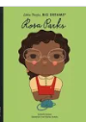
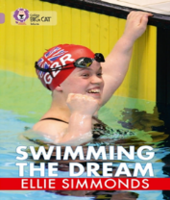
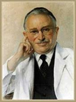
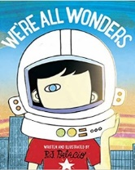
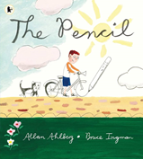
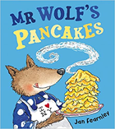
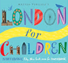
Year 2 Homework Autumn Term

Autumn 1 Topic: Where would you rather live Farnborough Village or London?
Autumn 2 Topic: What was the incredible impact of Sir Ludwig Guttman?

Homework activities are intended to be as open ended as possible, allowing the children to reflect on their learning in class in a creative way and for the children to make their own decisions on how to collect, record and present their home learning. We know from research that all pupils have different learning styles – some are visual learners, others work well with words and writing, many learn best from practical hands-on activities e.g. through making things, art or music. We know that children’s learning is maximised when they engage in activities using their individual learning styles.
Each week your child will be expected to complete a homework grid task. They can answer the question or complete the task in their own preferred way on one or two pages in their homework book. Here are some ideas of how children might approach learning grid activities:
- Drawing, colouring, sketches, labelled diagrams, artwork- painting, collage, 3D constructions
- Cooking with photographs or explanations
- Take photographs or even videos of their work
- Use the internet as a resource
- Tables, charts and grids
- Writing fiction, poems, descriptions
- Writing non-fiction-report, diary, letter, journal, newspaper report, e mail, leaflet, debate or explanation ● Invitations, postcard
- Your child can include objects or resources or references to them.

I hope you have fun learning.
These activities are either linked to your topic or give you the opportunity to do things that really matter with family and friends at home, whether it be having fun or being responsible in your house. These tasks need to be completed to the best of your ability. If a task is colour coded in blue, then the outcome needs to be presented in your homework book; if it is shaded in yellow, then no evidence is required in the book. Homework will be collected weekly on a Tuesday. You can choose which activity to complete.

 | Bloom’s Taxonomy - levels of thinking
 | Knowing  What do I know and understand? | Understanding  Can I apply and show what I know? | Creating What can I create? | Evaluating  Can I evaluate and make judgements?
Verbal  I enjoy reading, writing and speaking   | Measure and record the size of different body parts. E.g. length of finger, hand span, length of big toe etc.  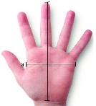 | Learn a London poem off by heart and perform it to your class.  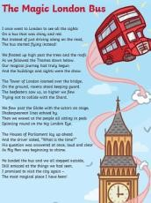 |   Create a short song to remember the Paralympian Values | Watch or read an advert for  food on the TV or on buses or magazines. Tell me about it: What is the food being sold? Who made the advert? What does the advert  suggest about the  food? What does the advert  want you to buy, do or  think?
Creative  I enjoy painting, drawing, making and listening to music   | Design a poster advertising London landmarks.  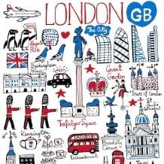 | Create a photo collage of The River Thames.  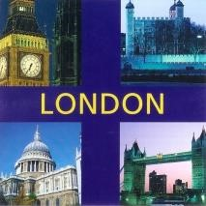 | Make a 3D London landmark model.  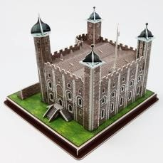 | Create a healthy snack or meal for the family. What would you include?
With my family  I enjoy working with others  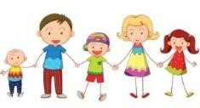 | Create a fact-file about one of the UK’s most successful Paralympians who have overcome challenges faced by their disability.   | Design a poster advertising the Paralympics in Farnborough Village. | Create a collage of Paralympian sports people from around the world. Include inspirational words that tell something about them. | Create your own poster or sculpture using fruit,  vegetables or plants inspired by Giuseppe Arcimboldo. Use this link to find out more:  https://artsmartforkids.wordpress.com/art-projects/giuseppe-arcimboldo/
On my own  I enjoy working by myself   | Design a new landmark for London.  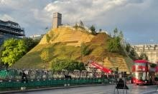 | Design the front of a postcard from London.   | Choose an organ or body part in the human body. Make a list of interesting facts about it.   | Turn your house into a restaurant for your  evening meal. You could create placemats, menus, decide how much you're going to charge your guests!

