22nd April 2024
Dear Parents,
Summer reading and maths homework
The children settled back quickly into their routines at school last week and we are very excited to get started.
For reading, your child will be sent home phonics activities to complete, the activities are linked to the sounds they practised at school the week before. A sound mat is also attached with this letter for your child to use and spot the focus sound for the week.
Your child learnt the sounds ie as in tie, ea as in sea, wh as in when, ph as in phonics and split digraph a_e as in late last week. Activities linked to these sounds are attached with this letter.
For maths this half term, we would like your child to practise counting in 2s up to 20, 5s up to 50 and 10s up to 100. This will help your child to become secure with the early stages of multiplication and division which they will start learning soon.
For the next two weeks, please can your child focus on counting forwards and backwards in 2s. You tube has catchy songs to help your child with counting.
counting in 2s - YouTube

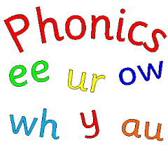
Thank you for your continued support.

Mrs Murray.

