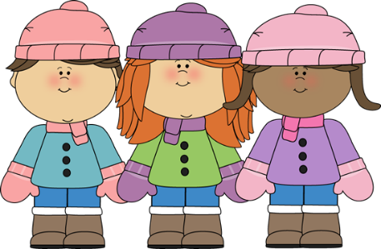
17th January 2023

Dear Parents,

Happy New year and thank you for your lovely, kind gifts and cards received before we broke up. We hope you’ve had a restful break.
Homework will begin this week, and details are attached with this letter.
During this term we will be starting to work on skills and strategies to support our Secret Agent Training (SATs) through reading, writing, maths and spellings.
Reading
As in the Autumn term, reading folders need to be brought in on Mondays and will be sent back Tuesdays. It is very important that children bring in their books weekly so we can support their reading journey at school while you support them at home.
Please take time when reading with your child, looking at the words, sounds and spellings of words. Always refer to the back of the front page where Bug Club gives the reader guidance how to best support the reader for the book in question. In addition, when you are reading with your child encourage your child to look at spelling patterns within words and become a word collector of interesting and exciting words they find, whilst they are reading which they could use in their own writing. Many great authors magpie ideas from others to create their masterpieces – JK Rowling used ideas from Greek myths to write the Harry Potter series!
Writing
To prepare for your child’s next piece of English writing, I am attaching a talk for writing text based on The River Unicorn. Please would you share this text with your child, read over it several times so your child can recite it independently. This will aid your child with English this term. Thank you.
Times Table Rock Stars
The TTRockstar challenge continues this term alongside reading. This app is extremely useful as it boosts children’s maths confidence and recall of multiplication and division facts. Please encourage your child to use the app as their increased times table knowledge will benefit their Secret Agent Training!
Spellings
In the Autumn term as part of the transition from Year 1 to Year 2 it was decided that children would not have spelling tests but there was an expectation that children would learn the spellings at school and at home.
This term in preparation for their Secret Agent Missions children will be having spelling tests based on weekly spelling patterns. Each week in class we will learn about the patterns, find words that follow the pattern and practise writing the words within our handwriting practice. They will then have their spelling test on Friday morning. The first test will be on 24th January.
On a lighter note, could the children that choose to go to Mr James’ Football Club on Tuesday and Thursday lunchtime bring in a change of footwear and a plastic bag to put muddy footwear in.
Finally, the children were unable to go to Forest School last week to burn their houses due to the windy weather. This has been rescheduled for Friday 20th January. Please can your child wear their PE clothes and bring in a change of footwear.
We would like to thank you for your continued support with your child and making a difference to your child’s learning.
Kind Regards,

Miss Morrison

P.S If you have any concerns regarding your child, please email me or catch me after school if you have any questions.

