Everyday Materials

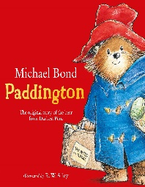
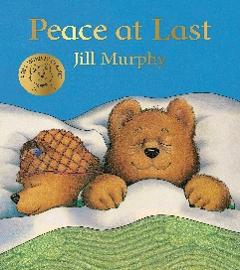
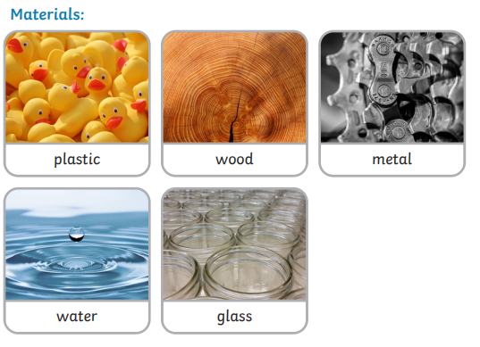
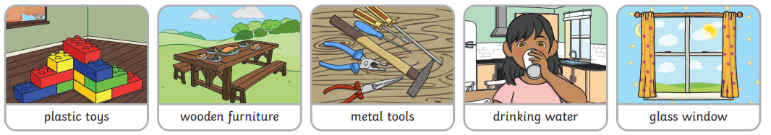
Year One Knowledge Organiser
Key Vocabulary
Object | An object is a material that can be seen or touched.
Materials | A material is the substance the object is made of.
Property | A property is the characteristic to describe materials.
Hard | A material that cannot be squashed.
Soft | A material that can be squashed.
Stretchy | A material that can be extended to a full length.
Stiff | A material that is difficult to fold or bend.
Shiny | A material that can reflect light.
Dull | A material that does not reflect light.
Opaque | A material that cannot be seen through.
Transparent | A material that can be seen through.
Rough | A surface of a material that is uneven.
Smooth | A surface of a material that is flat with no bumps.
Bendy | A material that is soft and bends easily into a curved shape.
Waterproof | A material that does not let water through.
Absorbent | A material that soaks up water.
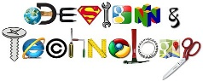
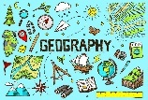
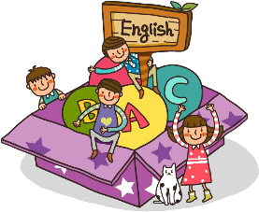
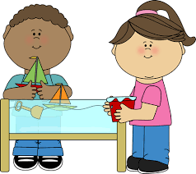
Why are everyday materials important to us?
