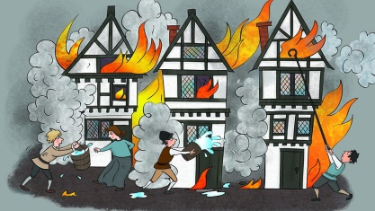
How did 1666 change London?
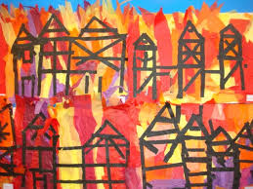
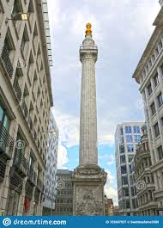
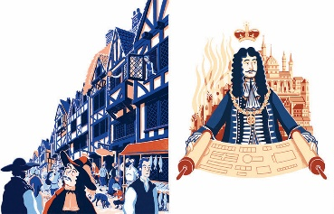
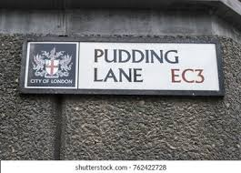
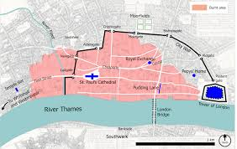
Year 2 Knowledge Organiser
Big Question | Subject Specific Vocabulary |  | Cross Curricular Links
How did 1666 change London?  Prior Knowledge  - What do you know about the Great Fire of London? | bakery | A place where bread or cakes are made and sold | Art: JW Turner  Painting with watercolour  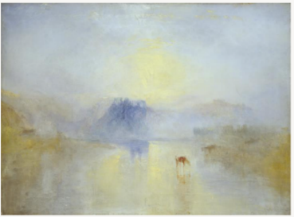  DT-Design, create and assess a house from 1666?  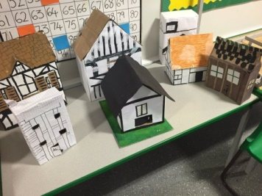
 | London | The capital city of England and the United Kingdom
 | River Thames | Many people got a boat on the River Thames to escape the fire
 | diary | A personal record of life’s events
 | eye-witness | A person who has seen something and can give a description of it
 | embers | Small pieces of glowing coal or wood in a dying fire
 | fire-hooks | Giant hooks used to pull down houses
 | fire-break | When buildings are destroyed to make a gap so the fire can’t spread
 | flammable | When something burns easily
 | St Paul’s Cathedral | A Christian building razed to the ground in the fire and rebuilt using designs by Sir Christopher Wren

