‘How did 1666 changed London?’ (London Today) Year 2 Knowledge Organiser
Big Question | Subject Specific Vocabulary |  | Cross Curricular Links
‘How did 1666 changed London?’  Prior Knowledge  - What do you know about London?  - How do you know this? | Capital City | A place where the central government of a country, or part of a country is. | Design and Technology  Design and create a functional Ferris wheel, learn how different components fit together so that the wheel rotates, and the structure stands freely.  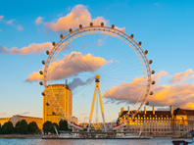
 | Landmark | An object or feature of a town that has importance or makes a place easily recognisable.
 | Skyline | The line or shape that is formed where the sky meets buildings or the land.
 | Tourist | A person who travels for pleasure.
 | Tourist Attraction | A place of interest where tourists visit.
 | Settlement | A settlement is an area where people live.
 | Human Features | Are things like houses, roads and bridges. They have been built by people.
 | Physical Features | Like lakes, hills and rivers are natural. They would be here even if there were no people around.
 | Compass | A tool that shows direction. ( North, South, East, West)
 | 