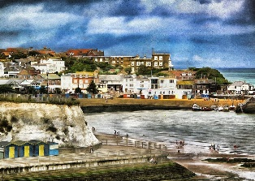
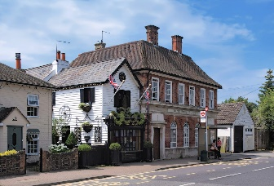
Oh I do like to be beside the seaside - or do I?
Year 1 Knowledge Organiser
Big Question | Subject Specific Vocabulary |  | Cross Curricular Links
Oh I do like to be beside the seaside – or do I?  Prior Knowledge  - What is the seaside?  - What do you see, hear, smell, and feel at the seaside? | geography | Geography is about earth and everything inside it. | Maths: Numbers in a seaside town and in our local area. What are numbers used for in a town or village? Which numbers can you spot in your local area?  Reading:  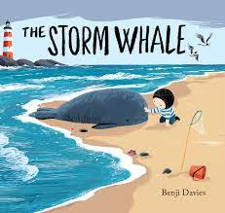  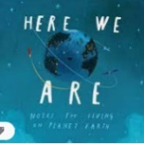
 | beach | A beach is made up of sand, rocks or pebbles and it is the land next to the sea.
 | seaside | The seaside is the land next to the sea.
 | coast | The coast is where the sea meets land.
 | local area | The local area is the area around where you live.
 | town | A town is where people and buildings are found. A town is larger than a village.
 | village | A village is where people and buildings are found. A village is smaller than a village.
 | house, housing | A house is a building where people live. There are different types of houses (detached, semi-detached, bungalow, cottage, flats, caravan, terraced)
 | cliff | A cliff is a mass of rock which is found next to the sea.
 | landmark | A feature or a place that is clearly visible or is easily recognised.
 | shop | A shop is a place where people buy goods like food, clothes and toys and services like a post office.
 | harbour | A harbour is a place where boats and ships are protected from the open sea.
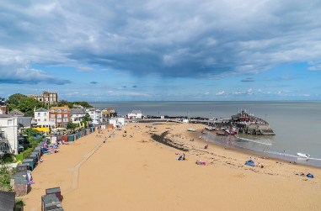 | direction | Direction when someone or something is pointing or moving (left, right, far, near) | 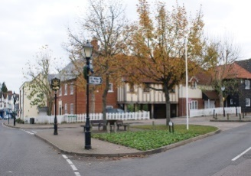
 | fieldwork | Fieldwork is an area where you collect information.
 | building | Buildings can be used for different things such as office, school, railway station, hospital, shops, doctor surgery, post office, restaurant, leisure centre.
 | Physical feature | A feature that occurred naturally.
 | Human feature | A feature made by people.

