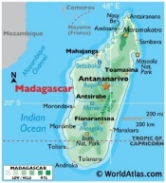
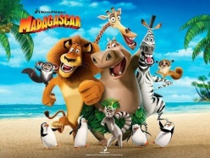

Year 2 Homework Topic: Madagascar v Greenland: which island would be easier to live on?
Homework activities are intended to be as open ended as possible, allowing the children to reflect on their learning in class in a creative way and for the children to make their own decisions on how to collect, record and present their home learning. We know from research that all pupils have different learning styles – some are visual learners, others work well with words and writing, many learn best from practical hands on activities e.g. through making things, art or music. We know that children’s learning is maximised when they engage in activities using their individual learning styles.
Each week your child will be expected to complete a homework grid task. They can answer the question or complete the task in their own preferred way on one or two pages in their homework book. Here are some ideas of how children might approach learning grid activities:
- Drawing, colouring, sketches, labelled diagrams, artwork- painting, collage, 3D constructions
- Cooking with photographs or explanations
- Take photographs or even videos of their work
- Use the internet as a resource
- Tables, charts and grids
- Writing fiction, poems, descriptions
- Writing non-fiction-report, diary, letter, journal, newspaper report, e mail, leaflet, debate or explanation
- Invitations, postcard
- Your child can include objects or resources or references to them.

We hope you have fun learning.

 | Bloom’s Taxonomy - levels of thinking
 | Knowing  What do I know and understand? | Understanding  Can I apply and show what I know? | Creating  What can I create? | Evaluating  Can I evaluate and make judgements?
Verbal  I enjoy reading, writing and speaking | Find a poem about a country that you would like to visit. Copy out one you enjoy and illustrate it. | Create your own travel brochure to encourage someone to visit a particular country. | Create a short song to remember the continents of the world. | You’ve booked a holiday and ended up in the wrong country. What would you do?
Creative  I enjoy painting, drawing, making and listening to music | Draw/paint a flag of a country that you are interested in. | Design a poster advertising a holiday to a destination of your choice. | Make a papier mache globe.  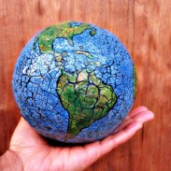 | Imagine that you are an explorer and that you have just discovered a new island. Draw a map of the island.
With my family  I enjoy working with others  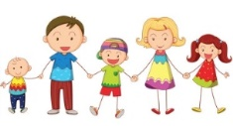 | Research and find out about a famous explorer of your choice. | Try a different food from around the world. | Create a tally chart. Which country would your family and friends most like to visit? | Find an adult’s favourite country on Google Earth. Ask them to explain why they have chosen the country that they have.
On my own  I enjoy working by myself | Design a new landmark for a country of your choice | Design the front of a postcard from a country that you have visited before. | Create a collage about your favourite country in the world. | Imagine that you are planning your holiday of a lifetime. Draw all the things that you would take in your suitcase.
These activities are either linked to your topic or give you the opportunity to do things that really matter with family and friends at home, whether it be having fun or being responsible in your house. These tasks need to be completed to the best of your ability. If a task is colour coded in blue, then the outcome needs to be presented in your homework book; if it is shaded in yellow, then no evidence is required in the book. Homework will be collected weekly on a Tuesday. You can choose which activity to complete.

