Homework – Friday 23rd April
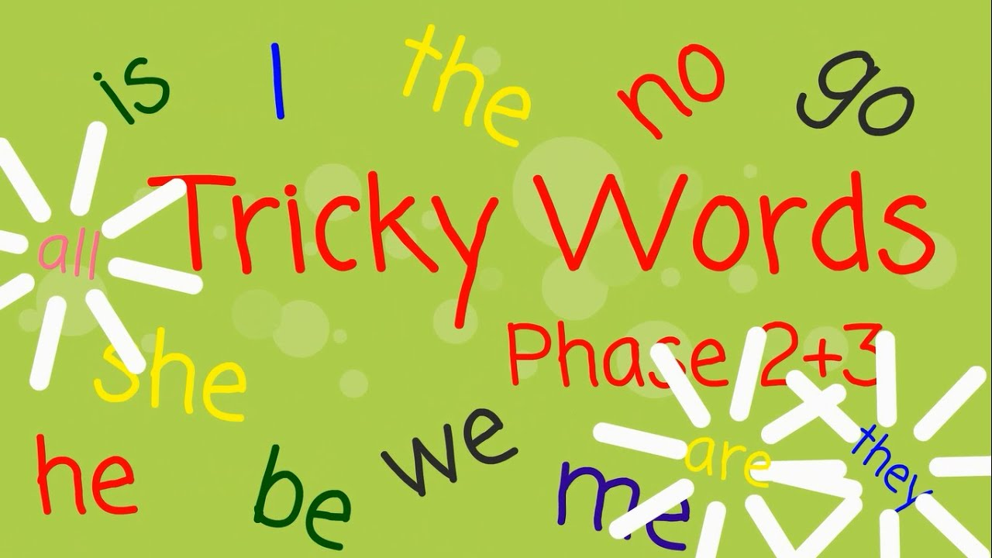

Please find, as separate attachments on the website, several Tricky Word mats, by phase – these are words that can’t be sounded out so have to be learnt by sight.
In school we have had a focus on Tricky Words this week, both reading and beginning to try to spell some of them correctly. So far we have covered reading all the words in Phases 2, 3 and 4, and for some children Tricky Words in Phase 5. We are working on spelling Phases 2 and 3 Tricky Words correctly for most children.
Please review at home the words your child knows and make a note of those you need to practise with them. If they can confidently read them you may like to check whether they can spell them correctly.
Please let us know how your child got on with this task by sending us a brief comment, by Monday, via e-mail.

receptionlearning@farnborough.bromley.sch.uk
Many thanks,
Mrs Holmes

