Homework – Friday 26th March 2021

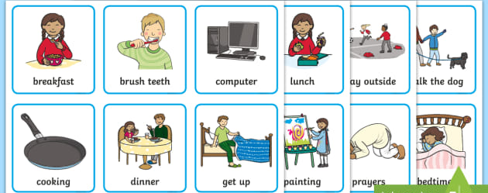

This week in Maths we have been learning about the concept of times of the day and the order of events in a day. We have been describing familiar events using the language of time eg first, then , next, later, before and after.
To consolidate this please could you help your child to make a timetable of a day from the weekend – you could draw pictures for each activity or take photographs. We use a visual timetable each day in school so they might like to create one for a day at the weekend.
Encourage your child to talk about the sequence of events using some of the language of time, or ask them questions eg do you clean your teeth before or after eating breakfast?
Some children may also wish to try to work out what time they do things by using a clock. We have been referring to this in class too.
Please send a comment on the Reception e-mail to let us know how your child got on with this task.
Many thanks,
Mrs Holmes

