Reception Timetable Week commencing – 22.2.21
 | Monday |  | Tuesday |  | Wednesday |  | Thursday |  |  | Friday
Daily Workout | Complete a CBeebies  Andy’s Wild Workout  https://www.bbc.co.uk/programmes/p06tmmvz |  | 5 a Day  https://player.5-a-day.tv/  User name – FPS53  Password – KS9vS3xd​ |  | Complete a yoga session  Cosmic Kids Yoga www.youtube.com/user/CosmicKidsYoga |  | 5 a Day  https://player.5-a-day.tv/  User name – FPS53  Password – KS9vS3xd​ |  |  | Complete one of the P.E or Fitness sessions on the  Joe Wicks Kids Workouts website
On-line daily Phonics lessons  Additional activities for Phonics | 9.00am  On-line phonics lesson  ( Consolidation and recap igh, oa )  Phonics powerpoints also available on website  Complete an activity in the Phonics Books supplied ( appropriate to your child’s ability )  Log onto Bug Club and read your next allocated book |  | 9.00am  On-line phonics lesson  ( Consolidation and recap oo,oo )  Phonics powerpoints also available on website  Play some Phonics games on Phonics Play  www.phonicsplay.co.uk  Username – jan21  Password – home  Click on Resources  Log onto Bug Club and read  your next allocated book |  | 9.00am  On-line phonics lesson  ( Consolidation and recap ar, or )  Phonics powerpoints also available on website  Complete an activity in the Phonics Books supplied ( appropriate to your child’s ability )  Log onto Bug Club and read  your next allocated book |  | 9.00am  On-line phonics lesson  ( Consolidation and recap ur, ow )  Phonics powerpoints also available on website  Play some Phonics games on Busy Things  www.busythings.co.uk  Username – home16000  Password – CHILD  Log onto Bug Club and read your next allocated book |  |  | 9.00am  On-line phonics lesson  (Tricky words consolidation and Tricky word bingo )  Phonics powerpoints also available on website  Complete an activity in the Phonics Books supplied ( appropriate to your child’s ability )  Log onto Bug Club and read your next allocated book
On-line daily  Writing sessions | 10.30am  On-line writing session |  | 10.30am  On-line writing session |  | 10.30am  On-line writing session |  | 10.30am  On-line writing session |  |  | 10.30am  On-line number writing session
Maths  Building  9 and 10 | Log on to  https://whiterosemaths.com /homelearning  Click on Early Years  Click on  Building 9 and 10 Week 1  Representing and Sorting  9 and 10  Click on Session 1 – watch the video and then complete the activity by clicking on  Get the Activity |  | Log on to  https://whiterosemaths.com /homelearning  Click on Early Years  Click on  Building 9 and 10 Week 1  Representing and Sorting  9 and 10  Click on Session 2 – watch the video and then complete the activity by clicking on  Get the Activity |  | Log on to  https://whiterosemaths.com /homelearning  Click on Early Years  Click on  Building 9 and 10 Week 1  Ordering numerals to 10  Click on Session 3 – watch the video and then complete the activity by clicking on  Get the Activity |  | Log on to  https://whiterosemaths.com /homelearning  Click on Early Years  Click on  Building 9 and 10 Week 1  Composition of numbers 9 and 10  Click on Session 4 – watch the video and then complete the activity by clicking on  Get the Activity |  |  | Log on to  https://whiterosemaths.com /homelearning  Click on Early Years  Click on  Building 9 and 10 Week 1  Numbers to 10 Bingo  Click on Session 5 – watch the video and then complete the activity by clicking on  Get the Activity
Afternoon activities based on our topic book of the week  Watch the story on You Tube  The Very Hungry Caterpillar  https://www.youtube.com/watch/75NQK-Sm1YY |  |  |  |  |  |  |  |  | 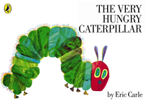
Writing  Attempts to write short sentences in meaningful contexts |  | Exploring and Using Media and Materials  Manipulates materials to achieve a planned effect |  | Wellbeing Wednesday |  | Understanding the World  Technology  Completes a simple programme on a computer |  | Health and self-care  Shows some understanding that exercise and eating can contribute to good health
Listen to the story  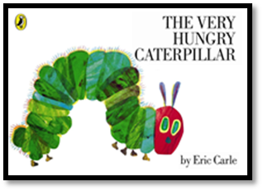  In the story the caterpillar eats lots of different foods.  Keep a food diary for yourself or your family for the week.  What was your favourite food of the week?  ( template on website )  Don’t forget to use your phonics knowledge, finger spaces and full stops.  Additional challenge  Use capital letters at the beginning of your sentence |  | Make your own caterpillar or butterfly  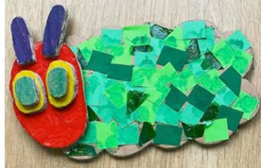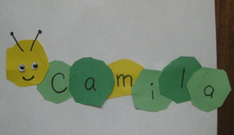  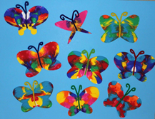  Butterfly template on website |  | Making Smoothies  Why not try a blindfold taste test before you make your Smoothie.  Can you identify all the fruits correctly?  Sample recipes on the website |  | Log into Busy Things  www.busythings.co.uk  Username – home16000  Password – CHILD  Upper Reception  Understanding the World  The World  Animals  Colour a bug  Select butterfly  You might also like to explore ….  The World  Food  Name vegetables  Name fruit |  | Watch the powerpoint about Healthy Living and Eating  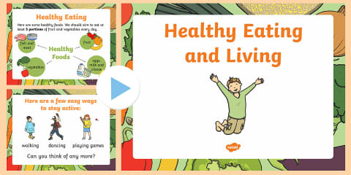  ( on the website )  Complete the activity  Sort the foods into Healthy, Unhealthy and a Mixture of Both  ( template on website )

