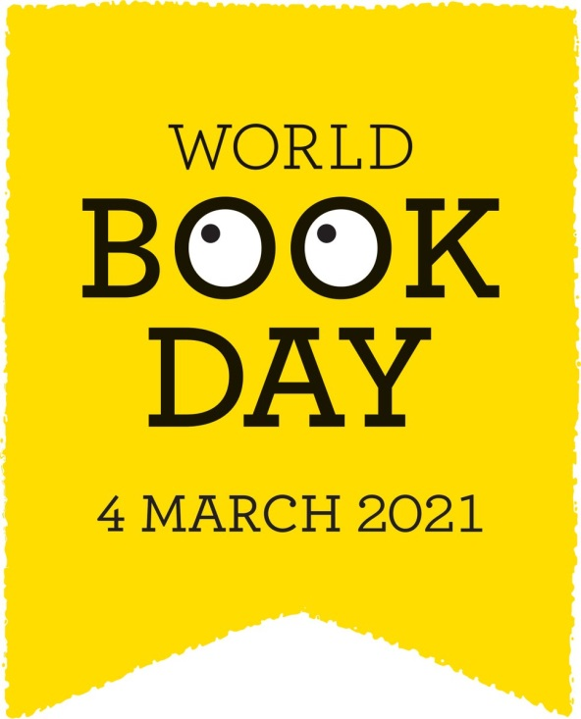

Friday 26th February
We would like to celebrate World Book Day over the course of next week ( as well as on the day itself ) by inviting the children to share some of their favourite books with the class.
Please talk to your child about their favourite book/s from home and why they like them so much in preparation for this. Maybe they could practise reading one of the pages or talking about an illustration that they really like.
Many thanks,
Mrs Holmes

