Reception Class Timetable – w/c 18.1.21
 | 8.45am  Exercise | 9.00am  Zoom  Phonics | 9.30am  Challenges | 10.00am  Story  10.15  Break | 10.30am  Zoom  Handwriting | 11.00am  Activities | 11.45am  Lunch | 12.45am  Maths  Comparing mass – heavier or lighter than | 1.15pm onwards  Activities
 | 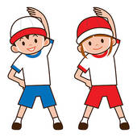 |  |  |  |  |  |  | 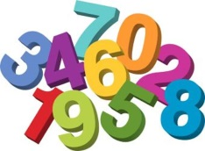
Monday | Daily Exercise | Phonics  oo  (long) | Phonics Challenges | Story Time  Fruit and Drink | Handwriting  oo  Phonics  Bingo | 121 Reading  Activities  Choosing Time |  | Maths  1  and  Activity | Dinosaur writing Activities  Choosing Time
Tuesday | Daily Exercise | Phonics  ar | Phonics Challenges | Story Time  Fruit and Drink | Handwriting  ar  Phonics Bingo | 121 Reading  Activities  Choosing Time |  | Maths  2  and  Activity | Outside Activity  Making a dinosaur out of natural materials
Wedn | Daily Exercise | Phonics  or | Phonics Challenges | Story Time  Fruit and Drink | Handwriting  or  Phonics Bingo | 121 Reading  Activities  Choosing Time |  | Maths  3  and  Activity | Salt dough dinosaur fossils  Activities  Choosing Time
Thursday | Daily Exercise | Phonics  ur | Phonics Challenges | Story Time  Fruit and Drink | Handwriting  ur  Phonics Bingo | 121 Reading  Activities  Choosing Time |  | Maths  4  and  Activity | ICT  Busy Things  Design a dinosaur  Achievement Assembly 2pm
Friday | Daily Exercise | Phonics  Recap | Phonics Challenges | Story Time  Fruit and Drink | Number  Writing  Number Bingo | 121 Reading  Activities  Choosing Time |  | Maths  5  and  Activity | Dinosaur skeleton using pasta  P.E session

