Reception Class Timetable – w/c 1.2.21 - Mental Health Week Book of the Week – Pass It On
 | 8.45am  Exercise | 9.00am  Zoom  Phonics | 9.30am  Phonics  Activities | 10.00am  Story  10.15am  Break | 10.30am  Zoom  Writing | 11.00am  Activities | 11.45am  Lunch | 12.45am  Maths  Making pairs  Combining 2 groups | 1.15pm onwards  Activities
 | 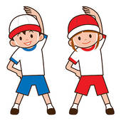 |  |  |  |  |  |  | 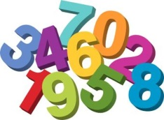
Monday | Daily Exercise | Mental Health Week story | Phonics activities | Story Time  Fruit and Drink | Show  and Tell | 121 Reading  Activities  Choosing Time |  | Maths  1  and  Activity | Making a book about what makes us happy
Tuesday | Daily Exercise | Phonics  oo  short | Phonics activities | Story Time  Fruit and Drink | Writing  oo  Phonics Bingo | 121 Reading  Activities  Choosing Time |  | Maths  2  and  Activity | Outside Activity  Making recycled bird feeders
Wedn | Daily Exercise | Phonics  er | Phonics activities | Story Time  Fruit and Drink | Writing  er  Phonics Bingo | 121 Reading  Making clay dinosaurs |  | Maths  3  and  Activity | Making a  Worry Toy
Thursday | Daily Exercise | Phonics  Consolidation | Phonics activities | Story Time  Fruit and Drink | Writing  Phonics Bingo | 121 Reading  Activities  Choosing Time |  | Maths  4  and  Activity | ICT  Designing a Superhero Achievement Assembly 2pm
Friday  Fancy Dress | Daily Exercise | Dress to Express | Phonics activities | Story Time  Fruit and Drink | Number  Writing  Number Bingo | 121 Reading  Activities  Choosing Time |  | Maths  5  and  Activity | P.E session  Whole School Talent Show

