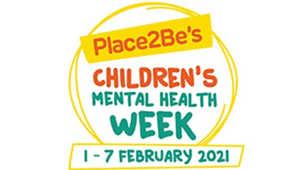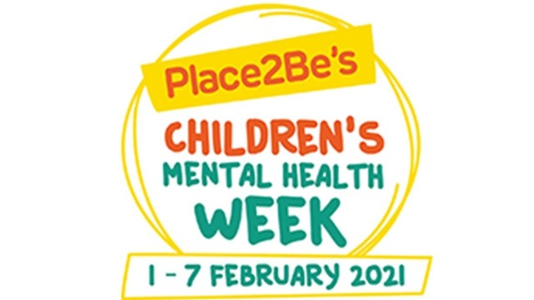
Thank you all again so much for everything you have been doing with your children at home – it has been great to get all your e-mails with details and photos of their work. Please keep these coming – we look forward to receiving them.
This week is Children’s Mental Health Week so we have added some different activities onto the timetable. Some of these activities are linked to general WellBeing eg the Nature task ( recycled bird feeders ) and Making a Worry toy and others are linked to the whole school Art Project of Superheroes.
As well as reviewing Monday’s Zooms ( as per the e-mail ) we will also celebrate Fancy Dress - Dress to Express on Friday at our normal 9.00am Zoom ( instead of Phonics ) so that the children can share what they’ve chosen to wear and talk about why. I’ve tried to make this clear on the Weekly Timetable.
Thank you so much to everyone who took part in the Class Talent show last week – who knew we had such a variety of skills! The Whole School Talent Show will take place on Friday with one entry going forward from Reception. Enjoy!
Any queries / comments at all please feel that you can continue to contact us via the reception e-mail address and if there is anything we can do to help or support you further please do let us know.
In the meantime please stay safe. We miss you all!
Mrs Holmes and the Reception Team
P.S Don’t forget about the Lego competition too.

