Homework – Friday 27th November 2020
These are three sounds we have learnt this week in phonics ( together with the actions ) and this means that we have now covered all the basic sounds of the alphabet. Please could you ask your child to repeat them to you at home and then look for things around the house and outside that begin with that sound. This will help reinforce the skill of hearing the initial sound in a word. They should also practise writing the letters – please use the catchy phrases that we have provided to help them with letter formation.
By now many children may also be ready to write some simple words / attempt a simple sentence using the letters they have learnt over the last few weeks. If so please encourage them to ‘have a go’ on a piece of paper.
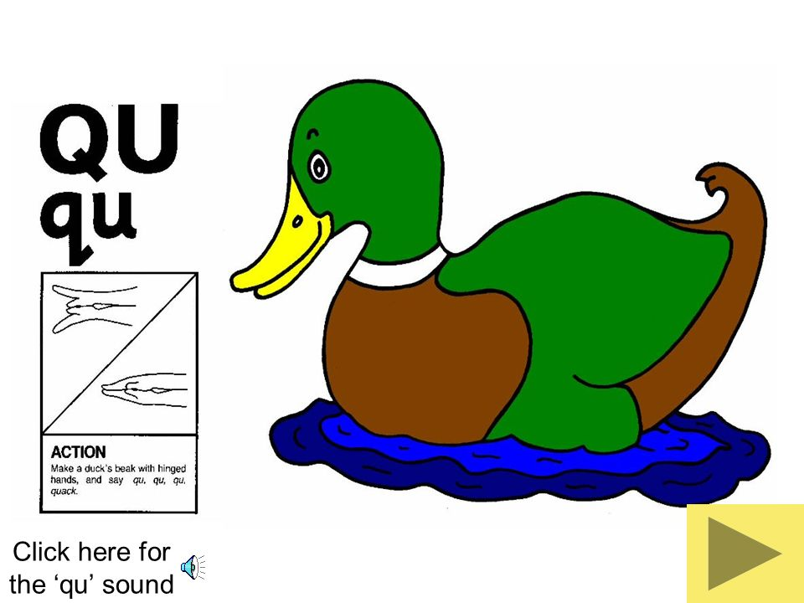 | 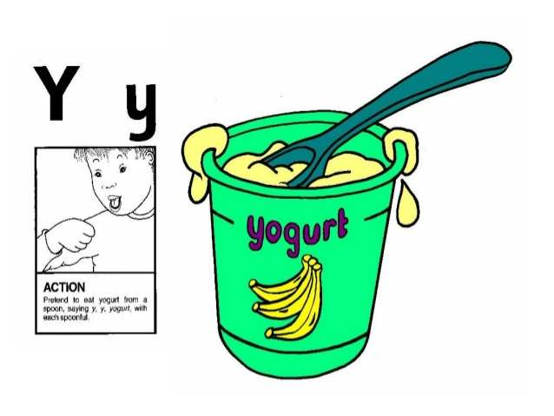
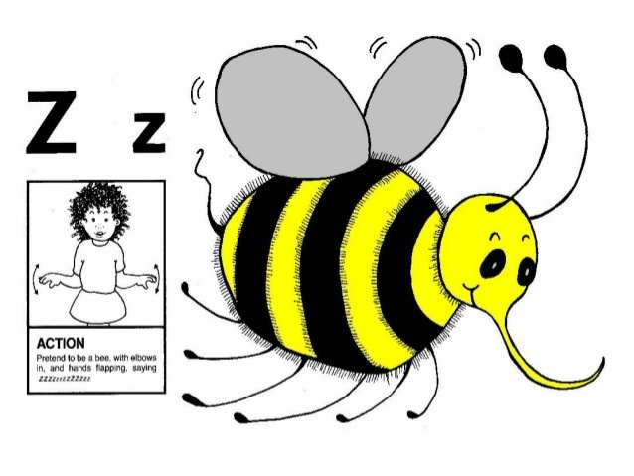

Please let us know how your child got on with this task by sending a brief comment, by Monday.
receptionlearning@farnborough.bromley.sch.uk
Many thanks,
Mrs Holmes
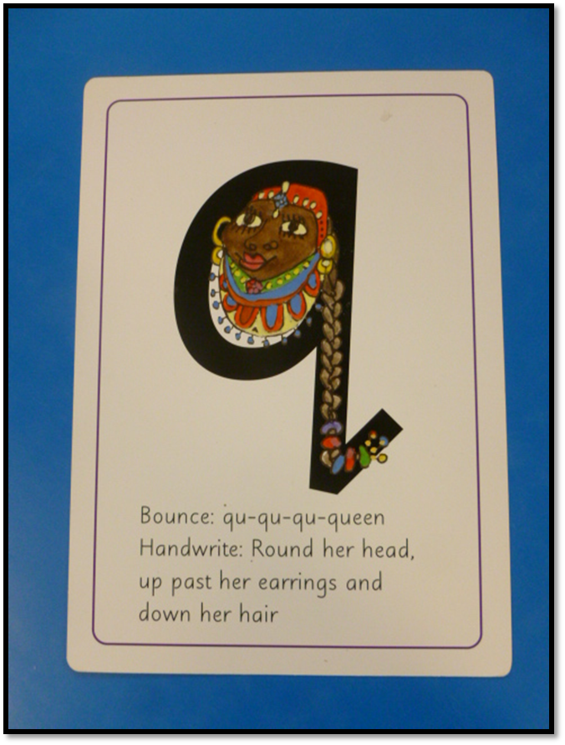 | 