Homework – Friday 9th October 2020
These are the four sounds we have learnt this week in phonics ( together with the actions ). Please could you ask your child to repeat them to you at home and then look for things around the house and outside that begin with that sound. This will help reinforce the skill of hearing the initial sound in a word. They should also practise writing the letters – please use the catchy phrases that we have included on the next page to help them with letter formation. We have started to teach the children the ‘pick and flick’ method to help them hold their pencil correctly – ask them to show you if they can. If you want to see it demonstrated copy and paste this link. Please ignore the song and the American accent– just watch the basic actions to give you an idea of how it works.
https://www.youtube.com/watch?v=DP5htYZ5jjQ
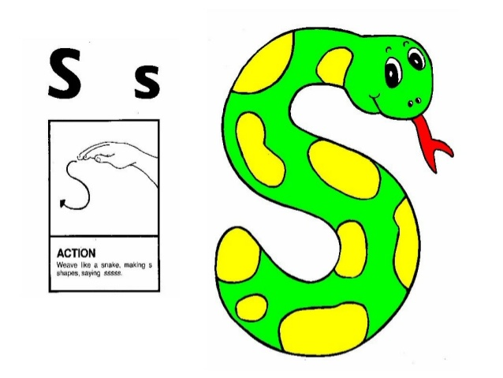 | 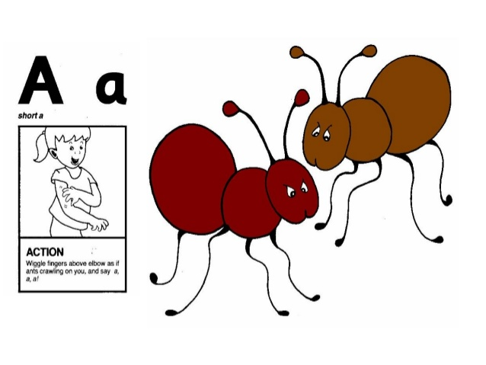
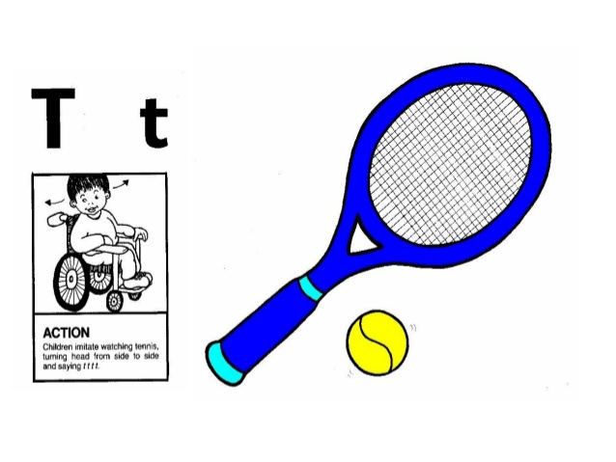 | 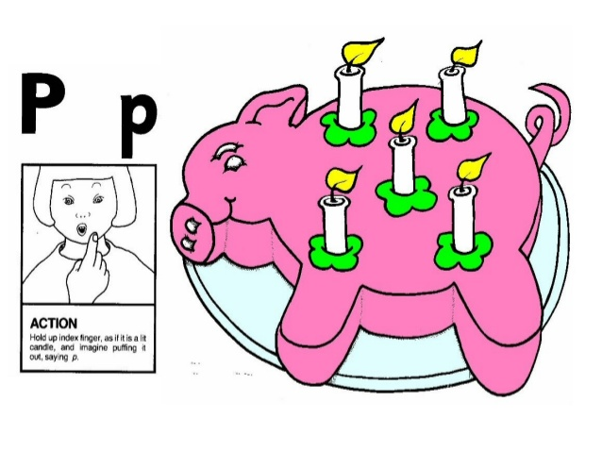

Please let us know how your child got on with this task by sending a brief comment, by Monday, to
receptionlearning@farnborough.bromley.sch.uk
Many thanks,
Mrs Holmes

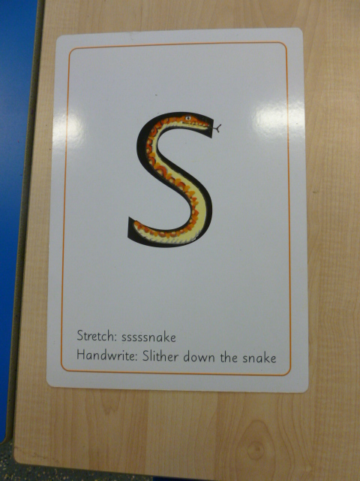 | 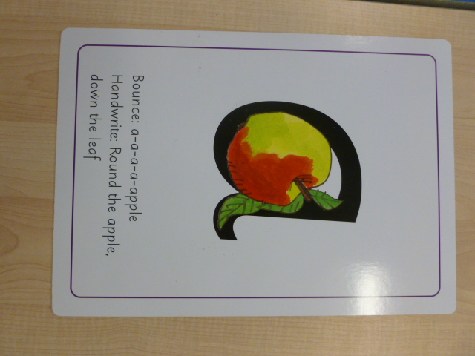
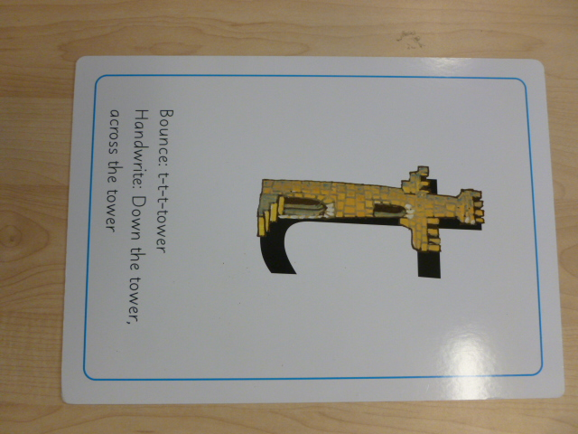 | 