Homework – Friday 16th October 2020
These are the four sounds we have learnt this week in phonics ( together with the actions ). Please could you ask your child to repeat them to you at home and then look for things around the house and outside that begin with that sound. This will help reinforce the skill of hearing the initial sound in a word. They should also practise writing the letters – please use the catchy phrases that we have provided on the next page to help them with letter formation. Some children may also be able to ‘ have a go ‘ at writing some simple CVC words using the eight letters they now know ( s, a, t, p, i, n, m, d ) eg pin, mat, tap, dad etc. Please encourage those that are ready to see how many they can do.
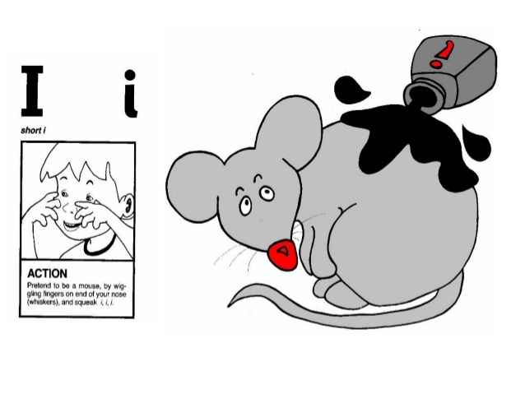 | 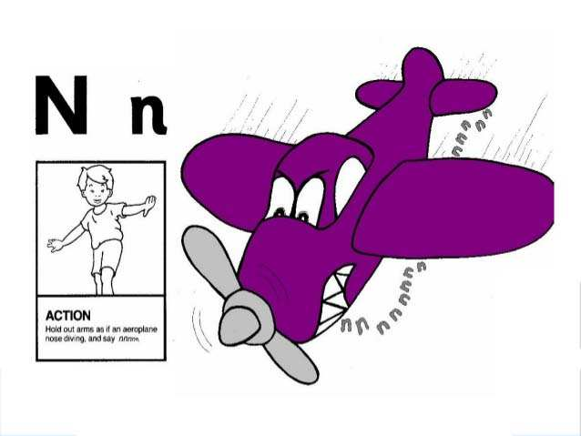
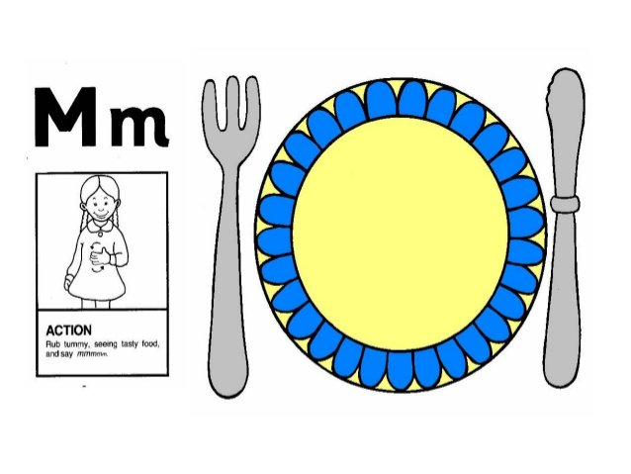 | 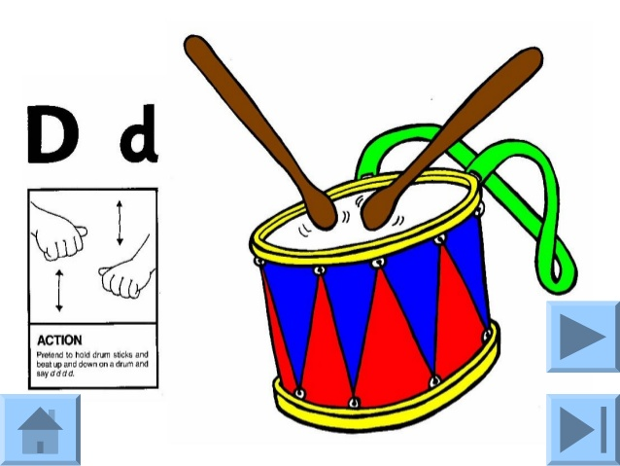

Please let us know how your child got on with this task by sending a brief comment, by Monday, to
receptionlearning@farnborough.bromley.sch.uk
Many thanks,
Mrs Holmes

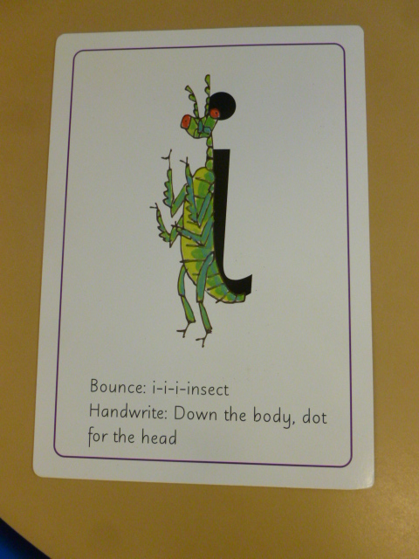 | 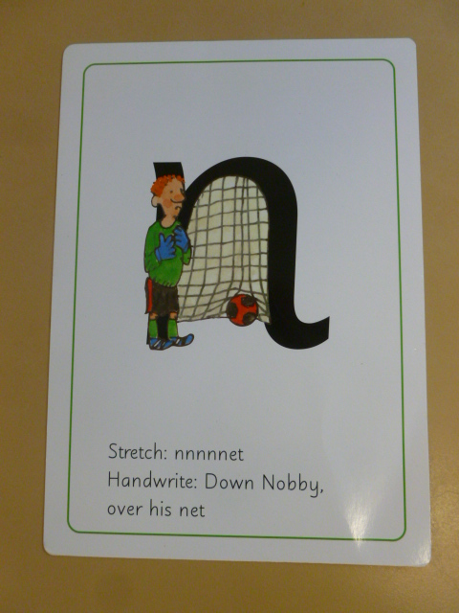
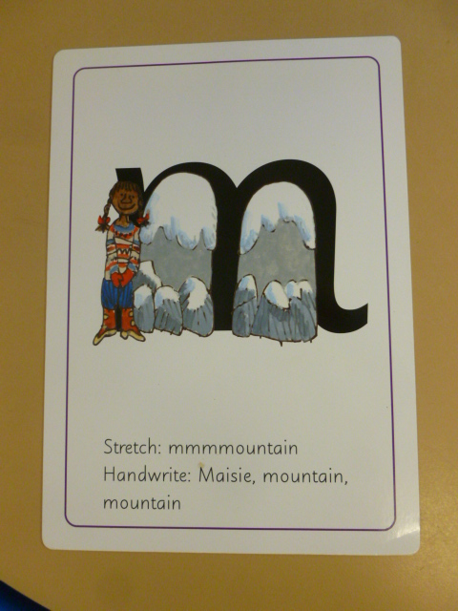 | 