Year 2 Homework Topic: Lively London 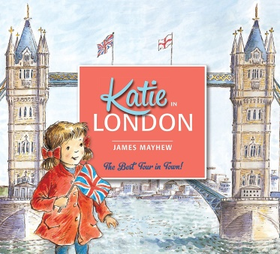 Book: ‘Katie in London’
Homework activities are intended to be as open ended as possible, allowing the children to reflect on their learning in class in a creative way and for the children to make their own decisions on how to collect, record and present their home learning. We know from research that all pupils have different learning styles – some are visual learners, others work well with words and writing, many learn best from practical hands on activities e.g. through making things, art or music. We know that children’s learning is maximised when they engage in activities using their individual learning styles.
Each week your child will be expected to complete a homework grid task. They can answer the question or complete the task in their own preferred way on one or two pages in their homework book. Here are some ideas of how children might approach learning grid activities:
- Drawing, colouring, sketches, labelled diagrams, artwork- painting, collage, 3D constructions
- Cooking with photographs or explanations
- Take photographs or even videos of their work
- Use the internet as a resource
- Tables, charts and grids
- Writing fiction, poems, descriptions
- Writing non-fiction-report, diary, letter, journal, newspaper report, e mail, leaflet, debate or explanation
- Invitations, postcard
- Your child can include objects or resources or references to them.

I hope you have fun learning.

 | Bloom’s Taxonomy - levels of thinking
 | Knowing  What do I know and understand? | Understanding  Can I apply and show what I know? | Creating  What can I create? | Evaluating  Can I evaluate and make judgements?
Verbal  I enjoy reading, writing and speaking | Read different poems about London; copy out one you enjoy and illustrate it. | Learn a London poem off by heart and perform it to your class. | Create another verse to ‘London’s Burning.’ | What would you do in London for a day?  Write a diary entry about your ideal day.
Creative  I enjoy painting, drawing, making and listening to music | Design a poster advertising The London Eye. | Create a photo collage of London landmarks. | Make a 3D London landmark model. | Paint a scene of the Great Fire of London.
With my family  I enjoy working with others | Research and try out a baking recipe. | Make a model of your own bakery. | Create a tally chart. How many of your friends and family have been on The London Eye or on a river cruise on the Thames? | Play a game or take part in a sport that you haven’t tried before. Would this game have been played in the past in London? Why?
On my own  I enjoy working by myself | Design a new landmark for London. | Design the front of a postcard from London. | Make a new shop sign for the bakery on Pudding Lane. Explain why you have chosen your sign. | Design a new English coin to commemorate the 353rd anniversary of The Great Fire of London
These activities are either linked to your topic or give you the opportunity to do things that really matter with family and friends at home, whether it be having fun or being responsible in your house. These tasks need to be completed to the best of your ability. If a task is colour coded in blue, then the outcome needs to be presented in your homework book; if it is shaded in yellow, then no evidence is required in the book. Homework will be collected weekly on a Tuesday. You can choose which activity to complete.

