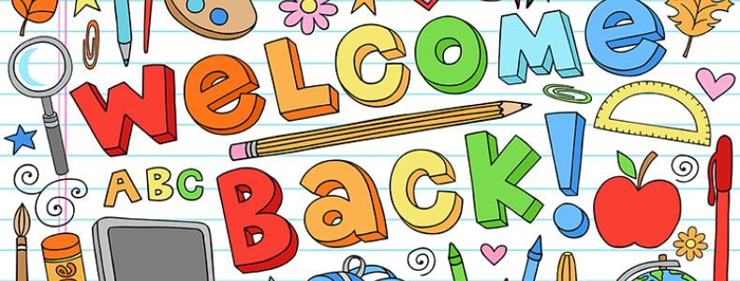Dear Griffins,
I am very excited that I am going to be teaching you from September and our new class name will be Genies.
In my PowerPoint, I shared somethings you may not know about me and some of the things that I did during lockdown. I would really like to get to know you a little better before we actually meet as a class so to help me to get to know you better, I would really like it if you could tell me about yourself. This could be in any creative way you would like, some ideas would be; a letter, pictures, posters, PowerPoints etc.
Although I worked with you when you were in Year 2, it will be lovely to get to know you all properly and to see how much you have grown. I have heard about some of the fantastic things you have done in Year 4 and I am excited about all of fun and exciting things we will learn about in Year 5.
Best Wishes,
Mrs Cheeseman

