Dear Giants,
Welcome to the School of Centaurs. I am very excited that you will be joining this establishment at the beginning of the new school year. This school is renowned for promoting a joy for learning and harnessing children’s natural curiosity to learn. We specialise in making learning experiences unforgettable.
As an introduction I will be sharing information about myself in a PowerPoint. However I would really like to get to know you a little better before we actually meet as a class. I would really like it if you could tell me about yourself in a creative way: a letter, pictures, posters, PowerPoints etc. All will be greatly received. I enjoy finding out about people.
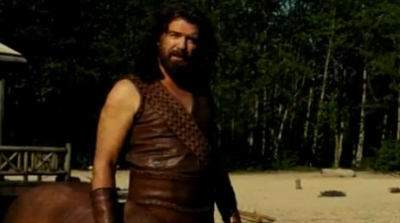
Although I have taught some of your siblings in the School of Centaurs; visited your class and watched you do maths. It will be lovely to get to know you all properly. I have seen some of the fantastic things you have done in Giants and I am excitedly looking forward to all of the fun and thrilling things we will do and learn about in Centaurs.
Best Wishes,
Miss Morrison

