Wellbeing Calendar by Years 3 and 4
Get creative | Get active | Try something new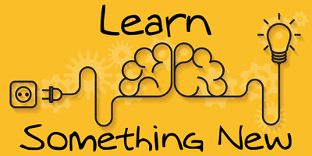 | 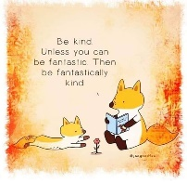  Be kind | Become more skilful  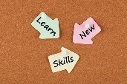
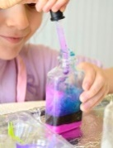  Creating and making potions | Design a PE workout for the class to complete – either inside or outside | Have a themed day with themed activities and food, e.g. Romans, Vikings, French, Italian | 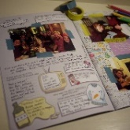  Make a photo book  of memories | 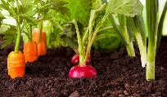  Learn to garden and plant flowers and vegetables – care for them and watch them grow
Make your own comic or Top Trump  cards | Photo challenge walk/quiz – take a picture or write down how many things you can find on a walk | 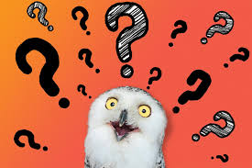  Make a quiz for your family e.g. household noises | 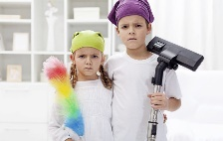  Offer to help with housework chores to help adults in the house | Learn to knit, cross stitch or sew a tapestry
Make a den and furnish it  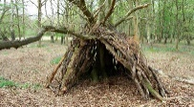 | Learn a new sport, e.g. rugby, badminton, yoga/go for a bike ride | Study the night sky and learn about the stars, planets and constellations | Write a letter to a member of your family or friend saying why you value them so much | 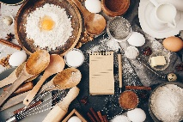  Bake cakes, flapjacks, shortbread, biscuits, mug cakes, make ice cream or fruit smoothies
Playing consequences in a small group; either the drawing or the writing version | Use a Fitbit and aim to reach 10,000 steps a day | 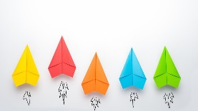  Make paper aeroplanes and have a competition to see whose can fly the furthest | Help a member of your family with their reading/drawing/cooking | Learn a new times table/beat your current score on Times Table Rock Stars
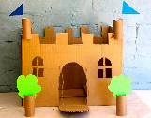  Make a fort or castle | Design some Olympic sports games – e.g. with a slinky, ping pong balls, straws etc | 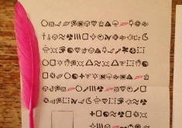  Challenge your family members to crack your secret coded messages! | 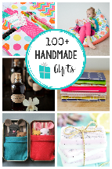  Make someone a gift, e.g. a card, a drink, some food | 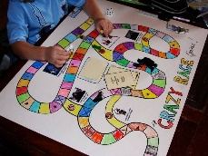  Learn some new board or card games

