Phase 5 Phonics
The Phase 5 phonics powerpoints are no longer available on the Home Learning site but for those of you that wish to carry on you may find the following information useful. The Phase 5 graphemes are as follows…ay ( day ), ou ( out ), ie ( tie ), ea ( eat ) , oy ( boy ), ir ( girl ), ue ( blue ), aw ( saw ), wh ( when ), ph ( photo ), ew ( new ), oe ( toe ), au ( Paul ) and then split digraphs a-e ( make ), e-e ( these) , i-e ( like) , o-e ( home ), u-e (rule )
Most of these are covered by Geraldine the Giraffe - she will be familiar to the children as we used the short clips, alongside other teaching strategies, when introducing the initial sounds. These could be used as an alternative to give the children an overview of the new sound and can be found by simply searching Geraldine the Giraffe learns , followed by the grapheme you want to cover eg Geraldine the Giraffe learns /ue/ There are only two graphemes not covered by these videos – these are oe and e-e.
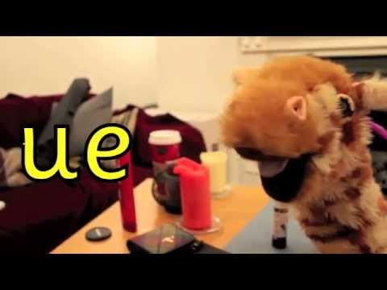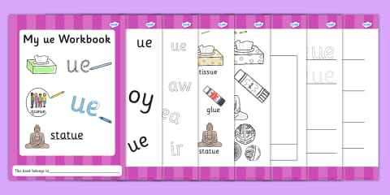
If you wish to continue with the Activity Books for each new sound these can be found on the Twinkl Website https://www.twinkl.co.uk/ Search - Phase 5 – type in the grapheme you want to cover – Grapheme Workbook eg Phase5 ue Grapheme Workbook
The Busy Things and Phonics Play websites also provide opportunities for the children to practise their Phase 5 Phonics. Busy Things – Upper Reception Set Up – Literacy, Communication and Language – Phonics Programme – Phase 5 / Busy Things - Year 1 – English – Phonics Programme – Phase 5 / Phonics Play – Phase 5 Interactive resources
Kind Regards, Mrs Holmes

