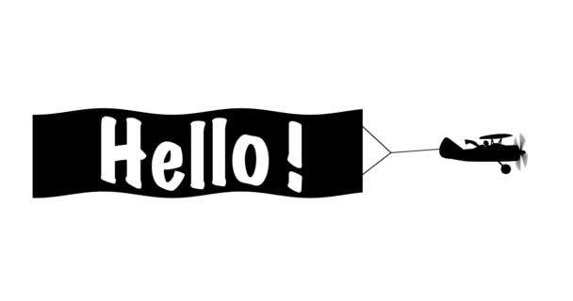
I hope you all had a good week last week – thank you to those of you who were able to join the Zoom session on Wednesday – it was great to see you! This week there will be a further two class Zoom sessions ( details on the website ) and one from Mr Atkinson on Friday about our Virtual Sports Day. As you will be aware some children are returning to school this week and therefore they will be joining the Zoom session from the classroom – if your child is not aware of this you may wish to let them know beforehand.
Just a reminder that if you want to carry on with Phase 5 phonics there is a message about this on Week 8 Home Learning and this week there is another whole school Art afternoon planned for Thursday and then Virtual Sports Day on Friday. I’ve also attached some additional outside activities ideas and details of free Home Learning resources on Music Express. Don’t forget we’ve also got the Race across the World too – we came third again last week. Well Done!
The year group e-mail will remain open until the end of the academic year and so you will still be able to share any work your child has completed at home, send messages and receive responses. As an extra incentive for the children house points are being awarded for good work / effort.
It is so lovely to hear from you - please keep sending in your messages to receptionlearning@farnborough.bromley.sch.uk
With my continued best wishes to you all, have a good week.
Mrs Holmes

