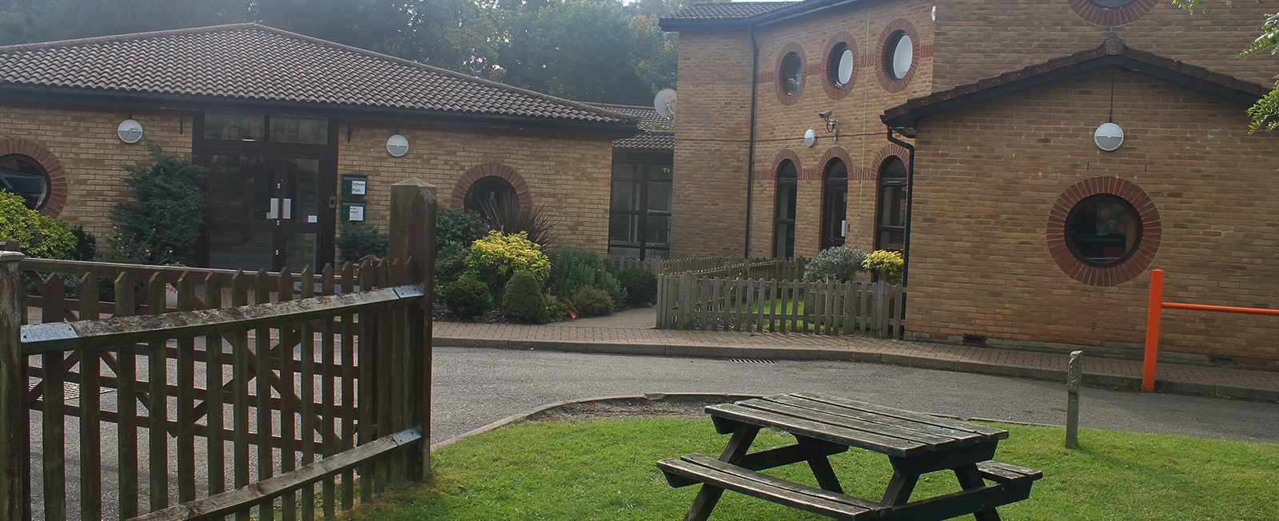
I hope you all had a lovely Half Term. We would love to hear or see what you got up to.
Thank you for sending your work in. It’s great to be able to see what you are up to and send you a message back. If you find a different task to do instead of the work set, I would love to see that as well. There is so much great stuff out there please feel free to try that out as well for a change from the set work. If you think it is really good please let me know as others may like to try it as well.
We are continuing with Active Challenge this week so remember to send in your totals. We will also be thinking about our transition to secondary school so start thinking about any questions you may have.
With our best wishes to you all, stay safe and well, Mr Atkinson and Mrs Brett

