Reception Activities Week commencing – 4.5.20
This week we are also adding into Home Learning ( for those that are ready and want to start ) Phase 5 Phonics – two new sounds per week – as well as sheets for those that want to begin to learn cursive handwriting.
Please carry on with the Phonics activities on the main Home Learning Timetable too to ensure your child continues to consolidate this knowledge at the same time.
Essentially there is a prepared powerpoint for each new sound - new graphemes and alternatives - eg ay for ai - and an adult will need to sit with their child to help them access this.
If there is a Jolly Phonics song / action this is included – please note that not all new sounds will have this. Some slides will have an icon to click on to make them more interactive – if there are any issues or queries once you try this just e-mail me on the Reception e-mail. I would also welcome any general feedback on how it works for you at home.
The powerpoints are loaded under Home Learning for Week 5.
The following day there will be an activity book to download to consolidate what your child learnt the previous day.
On Friday the focus will be on learning the new Phase 5 tricky words – these were added into your Home Learning Folder but there is also a link on the website under Home Learning this week if you need / want to download them.
 | Monday | Tuesday | Wednesday | Thursday | Friday
Phase 5 Phonics | Access the Powerpoint for  ay  (as in day)  on the website.  Share with  your child. | Complete Activity  Book for ay | Access the Powerpoint for  ou  (as in out)  on the website.  Share with  your child. | Complete Activity Book for ou | Begin to learn to read / write / put into sentences some of the Phase 5 Tricky words.
Cursive Handwriting 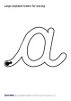 | Practise sheets available to download on the website
Reception Activities Week commencing – 4.5.20
 | Monday | Tuesday |  | Wednesday |  |  | Thursday | Friday
Daily Workout | 5 a Day  https://player.5-a-day.tv/  User name – FPS53  Password – JFz4XqG7 | Complete one of the P.E or Fitness sessions on the  Joe Wicks Kids Workouts  website |  | 5 a Day  https://player.5-a-day.tv/  User name – FPS53  Password – JFz4XqG7 |  |  | Complete a yoga session  on the  Cosmic Kids Yoga  website | 5 a Day  https://player.5-a-day.tv/  User name – FPS53  Password – JFz4XqG7
Phonics | Complete an activity in the Phonics Books supplied ( appropriate to your child’s ability ) | Sign on to the new Phonics website to play some phonics games  Teach your Monster to Read  ( see website for details ) |  | Complete an activity in the Phonics Books supplied ( appropriate to your child’s ability ) |  |  | Farnborough Primary School  Story Writing Day  See powerpoint on the website | VE Day  Activities  VE Colouring page  ( template on website )  Spitfire plane  ( template on website )  Union Jack Bunting  ( template on website )
*Reading | Log onto Bug Club and read your next allocated book | Log onto Bug Club and read your next allocated book |  | Log onto Bug Club and read your next allocated book
Writing | This week’s story is Jack and the Beanstalk. Draw a picture of what you’d like to find at the top of a beanstalk and write about it in your book. | Tricky Words  ( Phases 3/4 )  Ask an adult to do a Tricky Words Spelling Test with you!  How many did you get right? |  | Complete a page in the Handwriting Book or download from Twinkl  or try writing some cursive letters (templates on website)
Maths  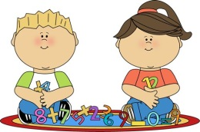 | Log into Maths with Parents  and complete the activity  Directions  Play Hide and Seek game | Play a game on  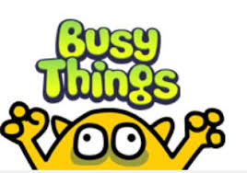  Maths  Space and Measures  Position and Direction |  | Positional Language Activity  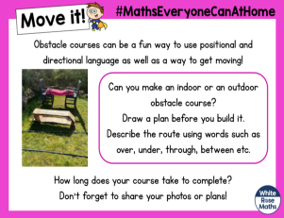  ( on website )
Book of the Week – Jack and the Beanstalk (available to watch on You Tube / read by Mrs Holmes on the school website)
Suggested additional activities | Act out the story of Jack and the Beanstalk. Ask a grown up to help you – who will be the giant?  Or use the stick puppets on the website. |  | Go on a leaf hunt – how many different shapes and sizes can you find?  ( leaf identification sheet on website ) |  | Complete the story map or match the right sentence to the right picture to tell the story.  ( various versions  on website ) | Make a castle out of resources you have at home or junk modelling |  |  | VE Day activities
* Please write the book title and a comment in your child’s Reading Record for each book read at home *
Free additional eBooks are also available on the Oxford Owl website https://www.oxfordowl.co.uk/

