Reading online | Log on to Bug Club and read for a minimum of 15 minutes.  Answer ‘bug’ questions.
Reading Comprehension | Complete the indicated page in your CGP Reading workbook.
Handwriting | Complete the indicated page in your CGP Handwriting workbook.
Grammar  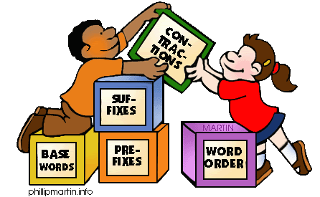 | Complete the indicated page in your Nelson Grammar workbook
English  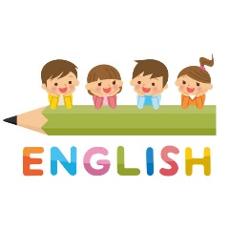 | Read through the English slides and complete the activity set in your orange exercise book.
Maths | Read through the Maths slides and complete the indicated pages in your CGP Maths Reasoning workbook.
Active Learning | PE, DT, Art, Science and Topic activities
Dear Parents,
Please see below work which will be set for your child in the event of a closure.

