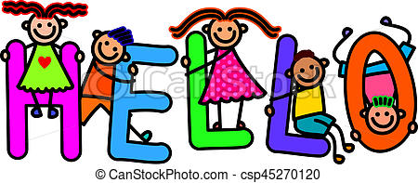
I just wanted to say a big hello to all of Unicorns Class and their families. I hope you are all well and coping in what is a challenging time for all of us.
It has been lovely to hear from some of you this week, via our admin e-mail, and to share what you’ve been getting up to at home. Thank you for all you are doing, it will make a huge difference when the children return to school.
I am very happy to respond to e-mails with little messages for the children if this helps over the coming weeks so please feel that you can continue to contact me via admin.office@farnborough.bromley.sch.uk
In the meantime keep up the good work at home and stay healthy.
With my best wishes to you all, Mrs Matthews

