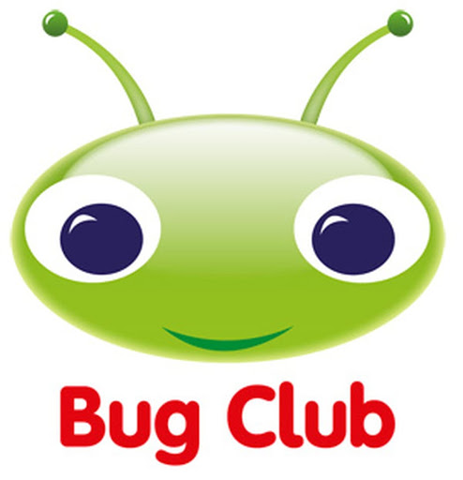
Thank you to everyone who is accessing the Bug Club website for reading books. Just a reminder that you need to read to the end of the book , and complete the questions by clicking on the ‘ bugs ’ , to make the book disappear from your allocation. If you don’t do this a new book won’t appear in ‘ My Stuff ‘.

