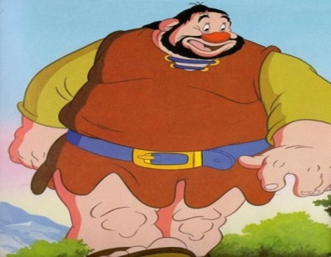
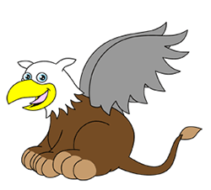

Dear Parents/Carers,
Welcome to Home Learning on the internet. This is in the event of a school closure. Below is a list of work that the children will be required to complete during this time.
Giants and Griffins will be continuing the hard work we have been completing at school at home for the next week.
Each day, you will have the following to complete:
- one piece of maths,
- one piece of reading
- one piece of writing
- spellings/handwriting practice
Each week you will also have:
- a history
- an art
- a science lesson.

Try to complete the work on a daily basis as if you were still in school rather than doing it all in one go.
On return to school we will be eager to look and mark the work you have completed, so remember to try your best and present your work neatly in your books you have been given. You can, of course, type and print your work out to stick in your books.
Additionally, please continue with reading daily and practising your times tables through Times Table Rock Stars, Hit the Button or a times table book.
We shall of course be returning to ‘Plastic Pirates’ so please continue to learn the song words and your individual spoken words.
We look forward to having you back in the classroom to continue our learning.
Yours sincerely
The Year 4 team
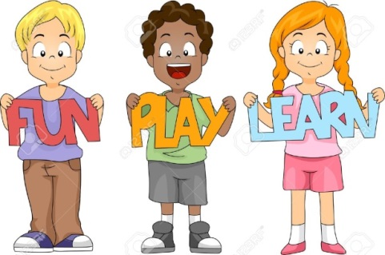
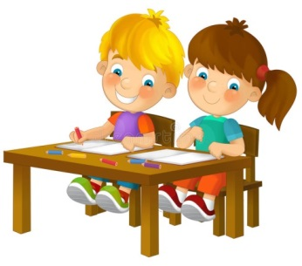
Mrs Browne Miss Pattison Mr Vallois

