Reading | Read for minimum of 20 minutes a day a book of your choice and record in your reading record.  For Guided Reading, read through the Reading slides and complete the activity set.
English  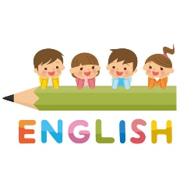 | Read through the English slides and complete the activity set.
Maths  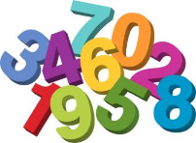 | Read through the Maths slides and complete the activity set. Additionally, Times Tables Rock stars can be practised daily and the website Topmarks has a selection of maths games that could be used to reinforce concepts being taught.
Science | Read through the Science slides and complete the activity set.
Active Learning  and Foundation subjects  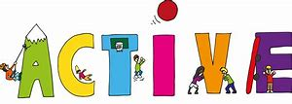 | PE activities  DT – Cooking, making  Art – drawing, sketching  French – Practise speaking conversational French  PSHE – Mindfulness meditation
Dear Parents,
Below shows the daily English, Maths and Reading work which will be set for your child in the event of the school being closed. Science, Topic, Active Learning activities and Foundation subjects will be set once a week. Please click on work link to find the slides.

