Homework – Friday 12th March 2021
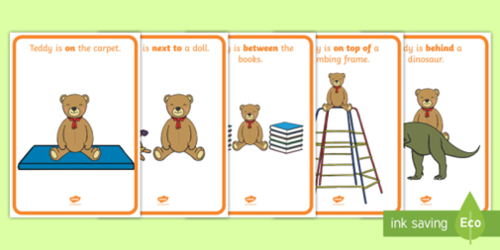
In Maths this week we have been learning about positional language eg on , next to, inside, under, on top, between , above, below etc.
For homework could you complete an activity with your child involving hiding a toy using positional language clues to help them find it, as detailed below.
- Find a small teddy or other toy, such as a car or a doll
- Let your child hide the toy somewhere in the house
- Ask questions about the location of the toy, starting with the room the toy is in eg Is it in the kitchen?
- Once you are in the correct room narrow the questionning down eg Is it behind the curtains? Is it under the cushion?
- Continue until the toy is found
- Then hide the toy yourself and let your child ask the questions. Encourage them to use positional language, as you did.
Please leave a short comment on the Reception Learning e-mail to let us know how your child got on with this task.
Many thanks, Mrs Holmes

