Reception Timetable Week commencing – 8.2.21 Celebrations - Chinese New Year
 | Monday |  | Tuesday |  | Wednesday |  | Thursday |  | Friday
Daily Workout | Complete a CBeebies  Andy’s Wild Workout  https://www.bbc.co.uk/programmes/p06tmmvz |  | 5 a Day  https://player.5-a-day.tv/  User name – FPS53  Password – KS9vS3xd​ |  | Complete a yoga session  Cosmic Kids Yoga www.youtube.com/user/CosmicKidsYoga |  | 5 a Day  https://player.5-a-day.tv/  User name – FPS53  Password – KS9vS3xd​ |  | Complete one of the P.E or Fitness sessions on the  Joe Wicks Kids Workouts website
On-line daily Phonics lessons  Additional activities for Phonics | 9.00am  Join us as a class to listen to our book about Chinese New Year  The Great Race  Find out which animal you are in the Chinese zodiac |  | 9.00am  Join Mrs Roberts and Key Stage 1 for an Assembly on  Safer Internet Day  Zoom log in e-mailed direct to parents |  | 9.00am  On-line phonics lesson  ( Consolidation and recap ch sh )  Phonics powerpoints also available on website  Complete an activity in the Phonics Books supplied ( appropriate to your child’s ability )  Log onto Bug Club and read  your next allocated book |  | 9.00am  On-line phonics lesson  ( Consolidation and recap th ng )  Phonics powerpoints also available on website  Play some Phonics games on Busy Things  www.busythings.co.uk  Username – home16000  Password – CHILD  Log onto Bug Club and read your next allocated book |  | 9.00am  On-line phonics lesson  ( Consolidation and recap ai ee)  Phonics powerpoints also available on website  Complete an activity in the Phonics Books supplied ( appropriate to your child’s ability )  Log onto Bug Club and read your next allocated book
 | Complete an activity in the Phonics Books supplied ( appropriate to your child’s ability )  Log onto Bug Club and read  your next allocated book |  | Play some Phonics games on Phonics Play  www.phonicsplay.co.uk  Username – jan21  Password – home  Click on Resources  Log onto Bug Club and read  your next allocated book
On-line daily  Writing sessions | 10.30am  On-line writing session |  | 10.30am  On-line writing session |  | 10.30am  On-line writing session |  | 10.30am  On-line writing session |  | 10.30am  On-line number writing
Maths  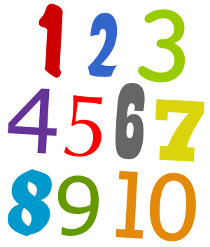  Length and Height  Time | Log on to  https://whiterosemaths.com /homelearning  Click on Early Years  Click on  Growing 6,7,8 Week 3  Comparing Height  Click on Session 1 – watch the video and then complete the activity by clicking on  Get the Activity |  | Log on to  https://whiterosemaths.com /homelearning  Click on Early Years  Click on  Growing 6,7,8 Week 3  Comparing Length  Click on Session 2 – watch the video and then complete the activity by clicking on  Get the Activity |  | Log on to  https://whiterosemaths.com /homelearning  Click on Early Years  Click on Growing 6,7,8 Week 3  Days of the Week  Click on Session 3 – watch the video and then complete the activity by clicking on  Get the Activity |  | Log on to  https://whiterosemaths.com /homelearning  Click on Early Years  Click on  Growing 6,7,8 Week 3  Measuring Height  Click on Session 4 – watch the video and then complete the activity by clicking on  Get the Activity |  | Log on to  https://whiterosemaths.com /homelearning  Click on Early Years  Click on  Growing 6,7,8 Week 3  Measuring Time  Click on Session 5 – watch the video and then complete the activity by clicking on  Get the Activity
Celebrating Chinese New Year – The Great Race  Listen to the story again on You Tube  https://www.youtube.com/watch?v=PbMxF9g8ga8  You can also watch the powerpoint all about the Chinese New Year ( available on the website ) |  |  |  |  |  |  |  | 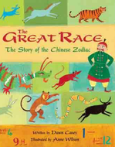
Writing  Attempts to write short sentences in meaningful contexts |  | Exploring and Using Media and Materials  Manipulates materials to achieve a planned effect |  | Exploring and Using Media and Materials  Manipulates materials to achieve a planned effect |  | Understanding the World  Technology  Completes a simple programme on a computer |  | Chinese New Year  Wear something red!
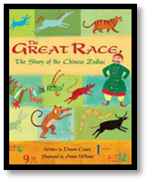  Think about the story we read today. Which animal were you?  Find out which animal the people in your family are ( you’ll need the year they were born ) and draw and write about these in your book.  Eg My mum was born in ….  She is a….  ( document on website to help find this information )  Don’t forget to use your phonics knowledge, finger spaces and full stops.  Additional challenge  Use capital letters at the beginning of your sentence |  | Make a Chinese lantern  ( Instructions on the website )  Outside Activity  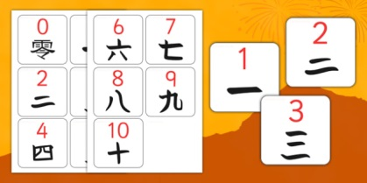  Download the sheet on Chinese numbers from the website.  Collect some sticks and see how many Chinese numbers you can make. |  | Make a chinese dragon  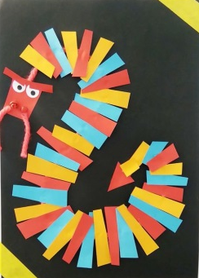  Chinese New Year is often celebrated with firework displays – have a go at this Science experiment to create your own fireworks  ( Instructions on the website ) |  | The Chinese Dragon Game is an ordering and sequencing numbers game based on the Chinese New Year dragon theme.  www.topmarks.co.uk  Search  Chinese Dragon Game  There are lots of other Chinese New Year activities on this site to explore  There are also some activities on Busy Things. Type Chinese New Year in the search bar to find them.  2pm  Achievement Assembly |  | Celebrate Chinese  New Year  Watch the clip on CBeebies  Preparing for Chinese New Year – Let’s celebrate  https://www.youtube.com/watch?v=c8ssHXZ9_qU  Hang your lantern and display your Chinese dragon  Make some Chinese Red Envelopes  ( templates on website )  Then why not enjoy a Chinese  meal with your family  ( recipe for Stir Fried Noodles on website )

