Reception Timetable Week commencing – 1.3.21
 | Monday |  | Tuesday |  | Wednesday |  | Thursday |  |  | Friday
Daily Workout | Complete a CBeebies  Andy’s Wild Workout  https://www.bbc.co.uk/programmes/p06tmmvz |  | 5 a Day  https://player.5-a-day.tv/  User name – FPS53  Password – KS9vS3xd​ |  | Complete a yoga session  Cosmic Kids Yoga www.youtube.com/user/CosmicKidsYoga |  | 5 a Day  https://player.5-a-day.tv/  User name – FPS53  Password – KS9vS3xd​ |  |  | Complete one of the P.E or Fitness sessions on the  Joe Wicks Kids Workouts website
On-line daily Phonics lessons  Additional activities for Phonics | 9.00am  On-line phonics lesson  ( Consolidation and recap oi, er )  Phonics powerpoints also available on website  Complete an activity in the Phonics Books supplied ( appropriate to your child’s ability )  Log onto Bug Club and read your next allocated book |  | 9.00am  On-line phonics lesson  ( Consolidation and recap ear, air )  Phonics powerpoints also available on website  Play some Phonics games on Phonics Play  www.phonicsplay.co.uk  Username – jan21  Password – home  Click on Resources  Log onto Bug Club and read  your next allocated book |  | 9.00am  On-line phonics lesson  ( Tricky words consolidation and Tricky Word bingo )  Phonics powerpoints also available on website  Complete an activity in the Phonics Books supplied ( appropriate to your child’s ability )  Log onto Bug Club and read  your next allocated book |  | 9.00am  World Book Day  Share your favourite book with the class |  |  | 9.00am  Welcome Back to School  What are we looking forward to?  Any questions?
 |  |  |  |  |  |  | **Log in at 10.30am** |  |  | **9.30am**  Whole School Assembly with Mrs Browne  World Book Day
 |  |  |  |  |  |  |  |  |  | Log onto Bug Club and read your next allocated book
Handwriting | Log onto Busy Things – Upper Reception - Literacy, Communication and Language – Handwriting - Choose an activity
Maths  Comparing numbers to 10  Bonds to 10 | Log on to  https://whiterosemaths.com /homelearning  Click on Early Years  Click on  Building 9 and 10 Week 2  Counting back from 10  Click on Session 1 – watch the video and then complete the activity by clicking on  Get the Activity |  | Log on to  https://whiterosemaths.com /homelearning  Click on Early Years  Click on  Building 9 and 10 Week 2  Comparing numbers within 10  Click on Session 2 – watch the video and then complete the activity by clicking on  Get the Activity |  | Log on to  https://whiterosemaths.com /homelearning  Click on Early Years  Click on  Building 9 and 10 Week 2  Comparing numbers within 10  Click on Session 3 – watch the video and then complete the activity by clicking on  Get the Activity |  | Log on to  https://whiterosemaths.com /homelearning  Click on Early Years  Click on  Building 9 and 10 Week 2  Making 10  Click on Session 4 – watch the video and then complete the activity by clicking on  Get the Activity |  |  | Log on to  https://whiterosemaths.com /homelearning  Click on Early Years  Click on  Building 9 and 10 Week 2  Making 10  Click on Session 5 – watch the video and then complete the activity by clicking on  Get the Activity
Writing  Attempts to write short sentences in meaningful contexts |  | Exploring and Using Media and Materials  Manipulates materials to achieve a planned effect |  | Wellbeing Wednesday |  | Understanding the World  Technology  Completes a simple programme on a computer |  | Reading  Enjoys an increasing range of books
What’s your favourite story?  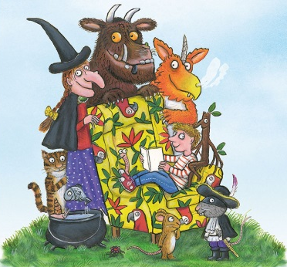  Draw a picture from the story in your book and then write about why it is your favourite book.  OR  Make your own story book  ( template on website )  Don’t forget to use your phonics knowledge, finger spaces and full stops.  Additional challenge  Use capital letters at the beginning of your sentence |  | Make an origami book corner  Copy and paste the link below  for instructions  https://www.youtube.com/watch?v=YVkJPCp_1UQ  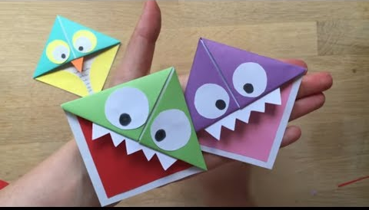  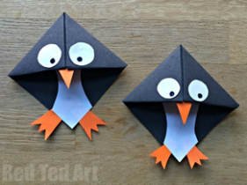  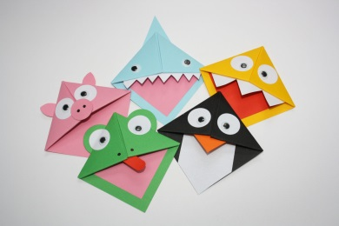 |  | Share a Story afternoon  Copy and paste the link below  to listen to some stories and get activities  https://www.worldbookday.com/share-a-story-corner/ |  | Log into Busy Things  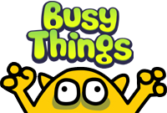  www.busythings.co.uk  Username – home16000  Password – CHILD  Upper Reception  Literacy, Communication and Language  Traditional Tales  Chose a story to explore  2pm  Whole School Assembly  with Miss James |  | World Book Day Scavenger Hunt  ( template on website )  Make something from Max’s  Monster Cookbook  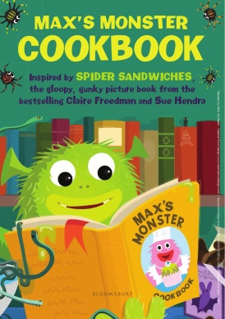  ( on the website )
Thank you for everything you have done with your children during Lockdown.
We are looking forward to welcoming them back to school.
The Reception Team

