Reception Class Timetable – w/c 8.2.21 - Celebrations – Chinese New Year , Book of the Week – The Great Race
 | 8.45am  Exercise | 9.00am  Zoom  Phonics | 9.30am  Phonics  Activities | 10.00am  Story  10.15am  Break | 10.30am  Zoom  Writing | 11.00am  Activities | 11.45am  Lunch | 12.45am  Maths  Length and Height  Time | 1.15pm onwards  Activities
 | 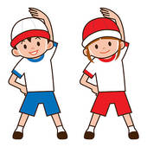 |  |  |  |  |  |  | 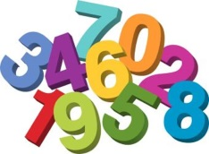
Monday | Daily Exercise | Chinese New Year story | Phonics activities | Story Time  Fruit and Drink | Writing  Phonics Bingo | 121 Reading  Activities  Choosing Time |  | Maths  1  and  Activity | Writing about the  12 animals in the Chinese Zodiac
Tuesday | Daily Exercise | Safer Internet Day Assembly | Phonics activities | Story Time  Fruit and Drink | Writing  Phonics Bingo | 121 Reading  Activities  Choosing Time |  | Maths  2  and  Activity | Outside Activity  Making Chinese numbers using natural materials
Wedn | Daily Exercise | Phonics  recap | Phonics activities | Story Time  Fruit and Drink | Writing  Phonics Bingo | 121 Reading  Making a Chinese lantern |  | Maths  3  and  Activity | Making a Chinese dragon  Fireworks  Science Experiment
Thursday | Daily Exercise | Phonics  recap | Phonics activities | Story Time  Fruit and Drink | Writing  Phonics Bingo | 121 Reading  Activities  Choosing Time |  | Maths  4  and  Activity | ICT  Chinese Dragon game  2pm Achievement Assembly
Friday  Chinese New Year | Daily Exercise | Phonics recap  Wear lucky red | Phonics activities | Story Time  Fruit and Drink | Number  Writing  Number Bingo | 121 Reading  Activities  Choosing Time |  | Maths  5  and  Activity | Celebrating Chinese New Year  P.E session

