Reception Timetable Week commencing – 25.1.21
 | Monday |  | Tuesday |  | Wednesday |  | Thursday |  |  | Friday
Daily Workout | Complete a CBeebies  Andy’s Wild Workout  https://www.bbc.co.uk/programmes/p06tmmvz |  | 5 a Day  https://player.5-a-day.tv/  User name – FPS53  Password – KS9vS3xd​ |  | Complete a yoga session  Cosmic Kids Yoga www.youtube.com/user/CosmicKidsYoga |  | 5 a Day  https://player.5-a-day.tv/  User name – FPS53  Password – KS9vS3xd​ |  |  | Complete one of the P.E or Fitness sessions on the  Joe Wicks Kids Workouts website
On-line daily Phonics lessons  Additional activities for Phonics | 9.00am  On-line phonics lesson  ( ow )  Phonics powerpoints also available on website  Complete an activity in the Phonics Books supplied ( appropriate to your child’s ability )  Log onto Bug Club and read your next allocated book |  | 9.00am  On-line phonics lesson  (oi )  Phonics powerpoints also available on website  Play some Phonics games on Phonics Play  www.phonicsplay.co.uk  Username – jan21  Password – home  Click on Resources  Log onto Bug Club and read  your next allocated book |  | 9.00am  On-line phonics lesson  ( ear)  Phonics powerpoints also available on website  Complete an activity in the Phonics Books supplied ( appropriate to your child’s ability )  Log onto Bug Club and read  your next allocated book |  | 9.00am  On-line phonics lesson  ( air )  Phonics powerpoints also available on website  Play some Phonics games on Busy Things  www.busythings.co.uk  Username – home16000  Password – CHILD  Log onto Bug Club and read your next allocated book |  |  | 9.00am  On-line phonics lesson  ( consolidation )  Phonics powerpoints also available on website  Complete an activity in the Phonics Books supplied ( appropriate to your child’s ability )  Log onto Bug Club and read your next allocated book
On-line daily  Writing sessions | 10.30am  On-line writing session |  | 10.30am  On-line writing session |  | 10.30am  On-line writing session |  | 10.30am  On-line writing session |  |  | 10.30am  On-line number writing session
Maths  Composition of  6,7 and 8  Matching 6,7 and 8  One more and one less | Log on to  https://whiterosemaths.com /homelearning  Click on Early Years  Click on  Alive in 5! Week 4  Composition of 6  Click on Session 1 – watch the video and then complete the activity by clicking on  Get the Activity |  | Log on to  https://whiterosemaths.com /homelearning  Click on Early Years  Click on  Alive in 5! Week 4  Sorting 6,7 and 8  Composition of 7  Click on Session 2 – watch the video and then complete the activity by clicking on  Get the Activity |  | Log on to  https://whiterosemaths.com /homelearning  Click on Early Years  Click on  Alive in 5! Week 4  Composition of 8  Click on Session 3 – watch the video and then complete the activity by clicking on  Get the Activity |  | Log on to  https://whiterosemaths.com /homelearning  Click on Early Years  Click on  Alive in 5! Week 4  Matching 6,7 and 8  Click on Session 4 – watch the video and then complete the activity by clicking on  Get the Activity |  |  | Log on to  https://whiterosemaths.com /homelearning  Click on Early Years  Click on  Alive in 5! Week 4  1 more and less  Click on Session 5 – watch the video and then complete the activity by clicking on  Get the Activity
Afternoon activities based on our topic book of the week

Listen to the story on You Tube
How to grow a Dinosaur
https://www.google.com/search?q=how+to+grow+a+dinosaur&oq=how+to+grow+a+dinosaur&aqs=chrome..69i57j46j0l2j0i395l4j46i395i412i424j0i395.6530j1j15&sourceid=chrome&ie=UTF-8
Writing  Attempts to write short sentences in meaningful contexts |  | Exploring and Using Media and Materials  Manipulates materials to achieve a planned effect |  | Maths  Uses familiar objects to create patterns |  | Understanding the World  Technology  Completes a simple programme on a computer |  |  | Being Imaginative  Creates simple representations of events, people and objects
Listen to the story  Imagine you found a dinosaur in your back garden. Which one would it be?  ( Dinosaur word mat on website )  What would you do with it?  Draw a picture of your dinosaur in your book and write about your day together.  Don’t forget to use your phonics knowledge, finger spaces and full stops.  Additional challenge  Use capital letters at the beginning of your sentence |  | Make your own dinosaur out of clay, plasticine or playdough  ( playdough recipe on the website )  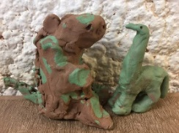  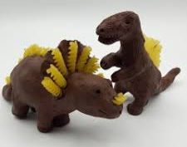  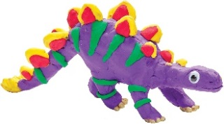  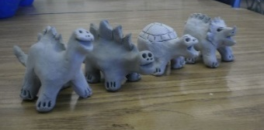 |  | Play a game of Dinosaur dominoes  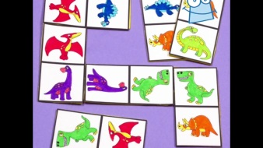  Template on the website  Wellbeing Wednesday Create a Music Video  Have fun! |  | Log into Top Marks  www.topmarks.co.uk  Search  Dinosaur Discovery  This is a fun, informative game about dinosaurs. Children can learn how dinosaurs protected themselves and how some were carnivores or herbivores.  The children might like to explore other games on this website too. |  |  | Make somewhere for your dinosaurs to live – inside or out!  