Reception Timetable Week commencing – 18.1.21
 | Monday | Tuesday | Wednesday | Thursday | Friday
Daily Workout  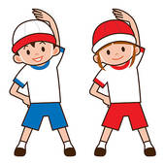 | Complete a CBeebies  Andy’s Wild Workout  https://www.bbc.co.uk/programmes/p06tmmvz | 5 a Day  https://player.5-a-day.tv/  User name – FPS53  Password – KS9vS3xd​ | Complete a yoga session  Cosmic Kids Yoga www.youtube.com/user/CosmicKidsYoga | 5 a Day  https://player.5-a-day.tv/  User name – FPS53  Password – KS9vS3xd​ | Complete one of the P.E or Fitness sessions on the  Joe Wicks Kids Workouts website
On-line daily Phonics lessons  Learning Objective  Reading  Can segment the sounds in simple words and blend them together  Links sounds to letters , naming and sounding the letters of the alphabet  Begins to read words and simple sentences | 9.00am  On-line phonics lesson  ( oo long )  Phonics powerpoints also available on website  Follow Up phonics challenges  Draw and label your favourite foods in your book  and / or  Try spooning some objects into a bottle  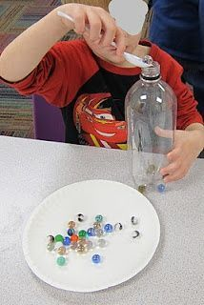 | 9.00am  On-line phonics lesson  ( ar )  Phonics powerpoints also available on website  Follow Up phonics challenges  Play the Piggy Bank game – ar  ( template on website )  and / or  Match the farm animals  to their young correctly  ( template on website ) | 9.00am  On-line phonics lesson  ( or)  Phonics powerpoints also available on website  Follow Up phonics challenges  Choose one or more of the pictures of things you might do in the morning  Write a sentence to go with the picture/s  and / or  Find some items from around your house and put them in order from short to long | 9.00am  On-line phonics lesson  ( ur )  Phonics powerpoints also available on website  Follow Up phonics challenges  Colour or collage a turtle  Write the word turtle next to it and underline the ur digraph.  ( template on website )  and / or  Play a turn taking game with an adult / sibling | 9.00am  On-line phonics lesson  ( consolidation )  Phonics powerpoints also available on website  Follow Up phonics challenges  Play Phase 2 or Phase 3  Tricky Word Bingo  Use the template on the website or make your own  ( templates on website )  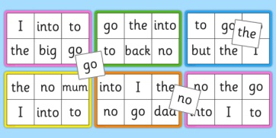  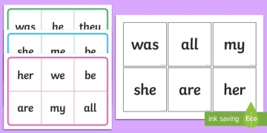
Additional activities for Phonics | Complete an activity in the Phonics Books supplied ( appropriate to your child’s ability ) | Play some Phonics games on Phonics Play  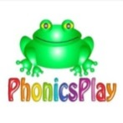  www.phonicsplay.co.uk  Username – jan21  Password – home  Click on Resources | Complete an activity in the Phonics Books supplied ( appropriate to your child’s ability ) | Play some Phonics games on Busy Things  www.busythings.co.uk  Username – home16000  Password - CHILD | Complete an activity in the Phonics Books supplied ( appropriate to your child’s ability )
On-line daily  Handwriting sessions  Learning Objective  Moving and Handling  Uses a pencil and holds it correctly to form recognisable letters, most of which are correctly formed | 10.30am  On-line handwriting session  ( alphabet mat, whiteboard, pen and rubber required )  Followed by  Phonics Bingo  Remember to  ‘ pick and flick ’ | 10.30am  On-line handwriting session  (alphabet mat, whiteboard, pen and rubber required )  Followed by  Phonics Bingo  Remember to  ‘ pick and flick ’ | 10.30am  On-line handwriting session  ( alphabet mat,  whiteboard, pen and rubber required )  Followed by  Phonics Bingo  Remember to  ‘ pick and flick ’ | 10.30am  On-line handwriting session  ( alphabet mat,  whiteboard, pen and rubber required )  Followed by  Phonics Bingo  Remember to  ‘ pick and flick ’ | 10.30am  On-line number writing session  ( whiteboard, pen and rubber required )  Followed by Number Bingo  Remember to  ‘ pick and flick ’
Additional activities for handwriting / number formation | Complete the  Capital Letters formation sheet  ( template on website ) | Complete a page in the Handwriting Book provided | Complete the  Writing Phase 2  Tricky Words  ( template on website ) | Complete a page in the Handwriting Book provided | Complete the number tracing activity  0-10 or 0-20  ( templates on the website )
Reading  Learning Objective  Reading  Begins to read words and simple sentences | Log onto Bug Club and read your next allocated book  Weekly 121  Reading Sessions  Individual date and time for this as advised by e-mail | Log onto Bug Club and read your next allocated book  Weekly 121  Reading Sessions  Individual date and time for this as advised by e-mail | Log onto Bug Club and read your next allocated book  Weekly 121  Reading Sessions  Individual date and time for this as advised by e-mail | Log onto Bug Club and read your next allocated book  Weekly 121  Reading Sessions  Individual date and time for this as advised by e-mail | Log onto Bug Club and read your next allocated book  Weekly 121  Reading Sessions  Individual date and time for this as advised by e-mail
Maths  Comparing mass – heavier or lighter than  Learning Objective  Shape, Space and Measures  Orders two items by weight or capacity | Log on to  https://whiterosemaths.com /homelearning  Click on Early Years  Click on  Alive in 5! Week 3  Or copy and paste  this link  https://whiterosemaths.com/homelearning/early-years/alive-in-5-week-3/  Click on Session 1 – watch the video and then complete the activity by clicking on  Get the Activity | Log on to  https://whiterosemaths.com /homelearning  Click on Early Years  Click on  Alive in 5! Week 3  Or copy and paste  this link  https://whiterosemaths.com/homelearning/early-years/alive-in-5-week-3/  Click on Session 2 – watch the video and then complete the activity by clicking on  Get the Activity | Log on to  https://whiterosemaths.com /homelearning  Click on Early Years  Click on  Alive in 5! Week 3  Or copy and paste  this link  https://whiterosemaths.com/homelearning/early-years/alive-in-5-week-3/  Click on Session 3 – watch the video and then complete the activity by clicking on  Get the Activity | Log on to  https://whiterosemaths.com /homelearning  Click on Early Years  Click on  Alive in 5! Week 3  Or copy and paste  this link  https://whiterosemaths.com/homelearning/early-years/alive-in-5-week-3/  Click on Session 4 – watch the video and then complete the activity by clicking on  Get the Activity | Log on to  https://whiterosemaths.com /homelearning  Click on Early Years  Click on  Alive in 5! Week 3  Or copy and paste  this link  https://whiterosemaths.com/homelearning/early-years/alive-in-5-week-3/  Click on Session 5 – watch the video and then complete the activity by clicking on  Get the Activity
Additional activities for maths | Play some Maths games on Busy Things  www.busythings.co.uk  Username – home16000  Password - CHILD | Complete an activity in the Maths Book supplied ( appropriate to your child’s ability) | Watch a CBeebies Number Blocks episode ( appropriate to your child’s ability)  https://www.bbc.co.uk/cbeebies/shows/numberblocks | Complete an activity in the Maths Book supplied ( appropriate to your child’s ability) | Play some Maths games on Busy Things  www.busythings.co.uk  Username – home16000  Password - CHILD
Topic activities  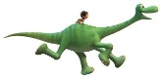  Dinosaurs! | Choose a dinosaur that you would like to find out more about. Use the internet or books to help you. Draw the dinosaur in your book and write a sentence / some sentences about something/s you found out about it.  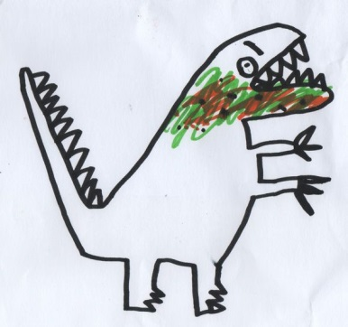  Challenge activity  Imagine you could meet your chosen dinosaur, what would you like to ask it?  Write the question/s in your book. | Listen to the book Dinosaur Bones  https://www.youtube.com/watch?app=desktop&v=XPvthRr31os  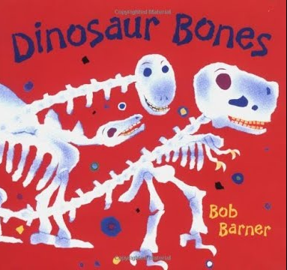  Did you find out anything that you didn’t know before?  Draw a picture and write about it in your book so that you remember it for later. | Make salt dough  dinosaur fossils  ( recipe on the website )  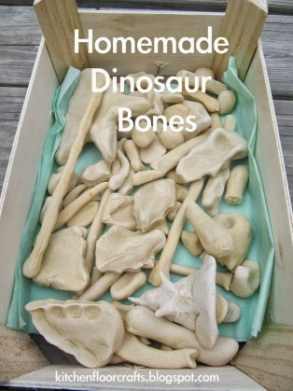  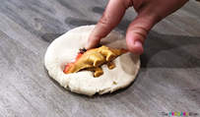  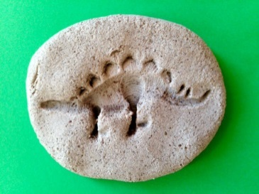 | Design your own dinosaur  Log into Busy Things  www.busythings.co.uk  Username – home16000  Password - CHILD  Click on  Key Stage 1  Year 1  Art  Make a ….  Characters and Animals  Dinosaur colouring | Build a dinosaur skeleton using pasta.  Can you give your dinosaur a name and tell us something about it?  Send us a photo!  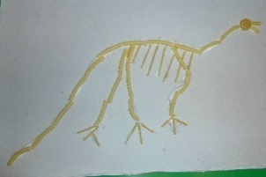  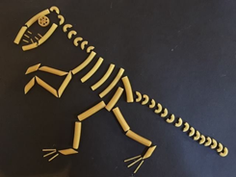  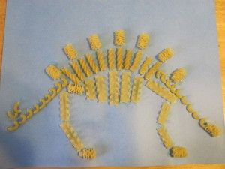  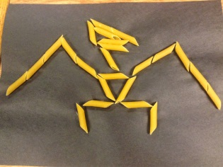
Weekly Fine Motor Skill Activity  Learning Objective  Moving and Handling  Handles tools, objects, construction and malleable materials safely and with continuing control | 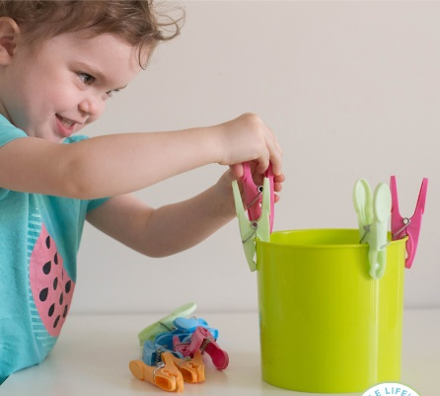  Pegs are great for building strength of fine motor muscle and coordination  How many pegs can you fit around a container?
Weekly Outdoor Activity  Learning Objective  Exploring and using media and materials  Understands that different media can be combined to create new effects  Manipulates materials to achieve a planned effect | Go into your garden or down to the woods and make your own dinosaur out of natural materials.  Send us a photo!  We’ll be doing the same in Forest School this week  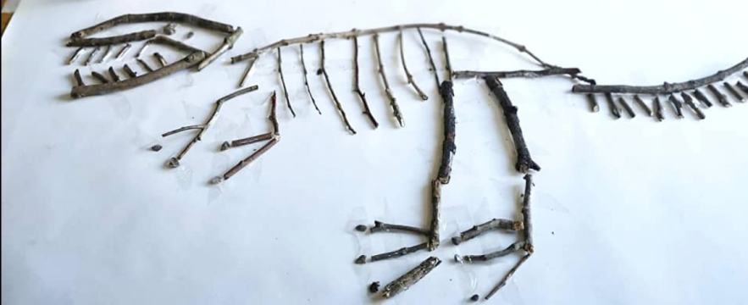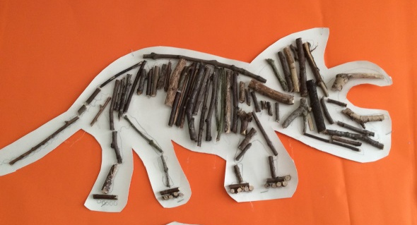  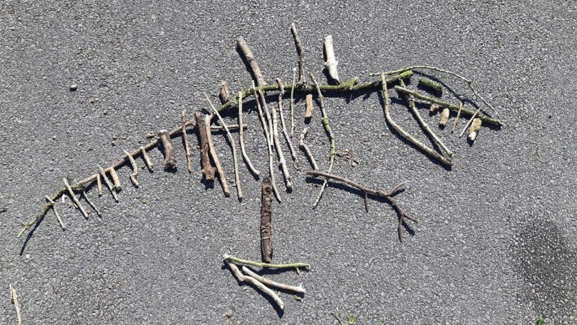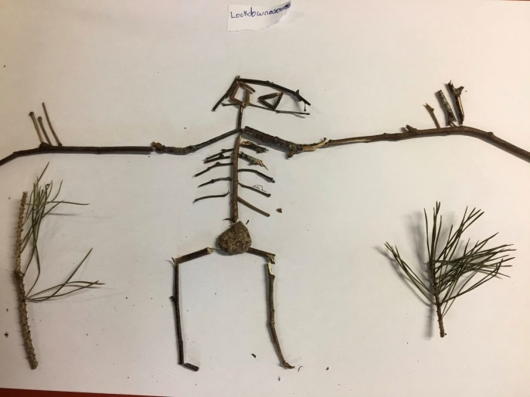

Thank you for all you are doing at home!
Stay safe
The Reception Team

