Reception Timetable Week commencing – 11.1.21
 | Monday | Tuesday | Wednesday | Thursday | Friday
Daily Workout  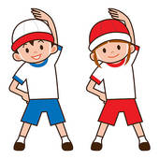 | Complete a CBeebies  Andy’s Wild Workout  https://www.bbc.co.uk/programmes/p06tmmvz | 5 a Day  https://player.5-a-day.tv/  User name – FPS53  Password – KS9vS3xd​ | Complete a yoga session  Cosmic Kids Yoga www.youtube.com/user/CosmicKidsYoga | 5 a Day  https://player.5-a-day.tv/  User name – FPS53  Password – KS9vS3xd​ | Complete one of the P.E or Fitness sessions on the  Joe Wicks Kids Workouts  website
On-line daily Phonics lessons  Learning Objective  Reading  Can segment the sounds in simple words and blend them together  Links sounds to letters , naming and sounding the letters of the alphabet  Begins to read words and simple sentences | 9.00am  On-line phonics lesson  ( ai )  Phonics powerpoints also available on website  Follow Up phonics challenges  Draw a snail in your book and label it / write a sentence to go with it.  and / or  Collage a snail or use pasta shapes to make the spiral shell or make a snail out of playdough  or plasticine.  Write a label to go  with your snail. | 9.00am  On-line phonics lesson  ( ee )  Phonics powerpoints also available on website  Follow Up phonics challenges  Order the days of the week  ( template on website )  What day of the week is it today?  and / or  Make a bee out of junk modelling.  Write a label to go with it. | 9.00am  On-line phonics lesson  ( igh)  Phonics powerpoints also available on website  Follow Up phonics challenges  Draw around your right hand and your left hand. Label them right and left.  and / or  Make a night time picture | 9.00am  On-line phonics lesson  ( oa )  Phonics powerpoints also available on website  Follow Up phonics challenges  Put the boats in the right size order and label your work  ( template on website )  and / or  Make a boat that  will float | 9.00am  On-line phonics lesson  ( consolidation )  Phonics powerpoints also available on website  Follow Up phonics challenges  Play Phase 2 Tricky Word Hunt  Write out these tricky words on different pieces of paper.  the  to  I  no  go  into  Ask an adult to hide them around your house and /or garden.  Use the sheet to tick them off as you find them ( template on website )
Additional activities for Phonics | Complete an activity in the Phonics Books supplied ( appropriate to your child’s ability ) | Play some Phonics games on Phonics Play  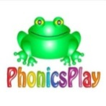  www.phonicsplay.co.uk  Username – jan21  Password – home  Click on Resources | Complete an activity in the Phonics Books supplied ( appropriate to your child’s ability ) | Play some Phonics games on Busy Things  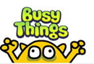  www.busythings.co.uk  Username – home16000  Password - CHILD | Complete an activity in the Phonics Books supplied ( appropriate to your child’s ability )
On-line daily  Handwriting sessions  Learning Objective  Moving and Handling  Uses a pencil and holds it correctly to form recognisable letters, most of which are correctly formed | 10.30am  On-line handwriting session  ( alphabet mat, whiteboard, pen and rubber required )  Followed by  Phonics Bingo  Remember to  ‘ pick and flick ’ | 10.30am  On-line handwriting session  (alphabet mat, whiteboard, pen and rubber required )  Followed by  Phonics Bingo  Remember to  ‘ pick and flick ’ | 10.30am  On-line handwriting session  ( alphabet mat,  whiteboard, pen and rubber required )  Followed by  Phonics Bingo  Remember to  ‘ pick and flick ’ | 10.30am  On-line handwriting session  ( alphabet mat,  whiteboard, pen and rubber required )  Followed by  Phonics Bingo  Remember to  ‘ pick and flick ’ | 10.30am  On-line number writing session  ( whiteboard, pen and rubber required )  Followed by Number Bingo  Remember to  ‘ pick and flick ’
Additional activities for handwriting | Complete the upper and lower letter formation sheet  ( template on website ) | Complete a page in the Handwriting Book provided | Complete the upper and lower letter formation sheet  ( template on website ) | Complete a page in the Handwriting Book provided | Complete the upper and lower letter formation sheet  ( template on website )
Reading  Learning Objective  Reading  Begins to read words and simple sentences | Log onto Bug Club and read your next allocated book  In addition we will conduct 121 Zoom reading appointments for children not attending school  Individual date and time for this as advised by e-mail | Log onto Bug Club and read your next allocated book  In addition we will conduct 121 Zoom reading appointments  for children not attending school  Individual date and time for this as advised by e-mail | Log onto Bug Club and read your next allocated book  In addition we will conduct 121 Zoom reading appointments  for children not attending school  Individual date and time for this as advised by e-mail | Log onto Bug Club and read your next allocated book  In addition we will conduct 121 Zoom reading appointments  for children not attending school  Individual date and time for this as advised by e-mail | Log onto Bug Club and read your next allocated book  In addition we will conduct 121 Zoom reading appointments  for children not attending school  Individual date and time for this as advised by e-mail
Maths  Comparing the composition of numbers to 5  Learning Objective  Numbers  Counts an irregular arrangement of up to 10 objects  Finds the total number of items in two groups by counting all of them  Records, using marks that they can interpret and explain | Log on to  https://whiterosemaths.com /homelearning  Click on Early Years  Click on  Alive in 5! Week 2  Or copy and paste this link  https://whiterosemaths.com/homelearning/early-years/alive-in-5-week-2/  Click on Session 1 – watch the video and then complete the activity by clicking on  Get the Activity | Log on to  https://whiterosemaths.com /homelearning  Click on Early Years  Click on  Alive in 5! Week 2  Or copy and paste this link  https://whiterosemaths.com/homelearning/early-years/alive-in-5-week-2/  Click on Session 2 – watch the video and then complete the activity by clicking on  Get the Activity | Log on to  https://whiterosemaths.com /homelearning  Click on Early Years  Click on  Alive in 5! Week 2  Or copy and paste this link  https://whiterosemaths.com/homelearning/early-years/alive-in-5-week-2/  Click on Session 3 – watch the video and then complete the activity by clicking on  Get the Activity | Log on to  https://whiterosemaths.com /homelearning  Click on Early Years  Click on  Alive in 5! Week 2  Or copy and paste this link  https://whiterosemaths.com/homelearning/early-years/alive-in-5-week-2/  Click on Session 4 – watch the video and then complete the activity by clicking on  Get the Activity | Log on to  https://whiterosemaths.com /homelearning  Click on Early Years  Click on  Alive in 5! Week 2  Or copy and paste this link  https://whiterosemaths.com/homelearning/early-years/alive-in-5-week-2/  Click on Session 5 – watch the video and then complete the activity by clicking on  Get the Activity
Additional activities for maths | Play some Maths games on Busy Things  www.busythings.co.uk  Username – home16000  Password - CHILD | Complete an activity in the Maths Book supplied ( appropriate to your child’s ability) | Watch a CBeebies Number Blocks episode ( appropriate to your child’s ability)  https://www.bbc.co.uk/cbeebies/shows/numberblocks | Complete an activity in the Maths Book supplied ( appropriate to your child’s ability) | Play some Maths games on Busy Things  www.busythings.co.uk  Username – home16000  Password - CHILD
Topic activities  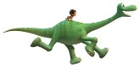  Dinosaurs! | Do you want to learn about dinosaurs?  Watch this video to find out more!  https://www.youtube.com/watch?v=RBaiG_7f7GQi | Watch the powerpoint  ‘Which dinosaur am I?’  ( details on website )  Draw your favourite dinosaur in your book and write a sentence about it. | Find some empty cardboard boxes and make your own dinosaur.  Send us a photo of your creation! | Label the dinosaurs  ( template on website ) | Make your own split pin dinosaurs  ( template on website )
Weekly Fine Motor Skill Activity  Learning Objective  Moving and Handling  Handles tools, objects, construction and malleable materials safely and with continuing control | 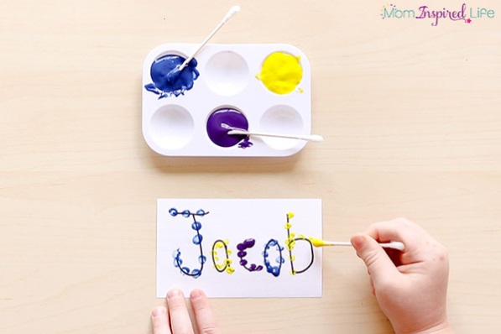  Use some q tips and paint to write your name.  What other words can you write?
Weekly Outdoor Activity  Learning Objective  Exploring and using media and materials  Understands that different media can be combined to create new effects  Manipulates materials to achieve a planned effect | Making nests  Can you create a nest for a dinosaur to lay its eggs?  In Forest School this week we’re going to try to make some nests out of natural materials. Why not have a go at home too and send us some photos?  More details on nest building on the website  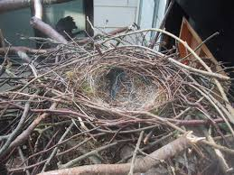

Thank you for all you are doing at home!
Stay safe
The Reception Team

