Reception Timetable Week commencing – 1.2.21 Children’s Mental Health Week – Express yourself
 | Monday |  | Tuesday |  | Wednesday |  | Thursday |  | Friday
Daily Workout  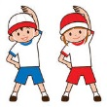 | Complete a CBeebies  Andy’s Wild Workout  https://www.bbc.co.uk/programmes/p06tmmvz |  | 5 a Day  https://player.5-a-day.tv/  User name – FPS53  Password – KS9vS3xd​ |  | Complete a yoga session  Cosmic Kids Yoga www.youtube.com/user/CosmicKidsYoga |  | 5 a Day  https://player.5-a-day.tv/  User name – FPS53  Password – KS9vS3xd​ |  | Complete one of the P.E or Fitness sessions on the  Joe Wicks Kids Workouts website
On-line daily Phonics lessons  Additional activities for Phonics | 9.00am  Join us as a class to listen to our book for Children’s Mental Health Week  Pass it On  An uplifting book about finding happiness in the smallest of things |  | 9.00am  On-line phonics lesson  (oo short )  Phonics powerpoints also available on website  Play some Phonics games on Phonics Play  www.phonicsplay.co.uk  Username – jan21  Password – home  Click on Resources  Log onto Bug Club and read  your next allocated book |  | 9.00am  On-line phonics lesson  ( er)  Phonics powerpoints also available on website  Complete an activity in the Phonics Books supplied ( appropriate to your child’s ability )  Log onto Bug Club and read  your next allocated book |  | 9.00am  On-line phonics lesson  ( Consolidation )  Phonics powerpoints also available on website  Play some Phonics games on Busy Things  www.busythings.co.uk  Username – home16000  Password – CHILD  Log onto Bug Club and read your next allocated book |  | 9.00am  Join us as a class for  Dress to Express Day  A chance to see what everyone is wearing and why
Complete an activity in the Phonics Books supplied ( appropriate to your child’s ability )

Log onto Bug Club and read your next allocated book

Complete an activity in the Phonics Books supplied ( appropriate to your child’s ability )

Log onto Bug Club and read
your next allocated book
On-line daily  Writing sessions | 10.30am  Whole Class  Show and Tell Session |  | 10.30am  On-line writing session |  | 10.30am  On-line writing session |  | 10.30am  On-line writing session |  | 10.30am  On-line number writing session
Maths  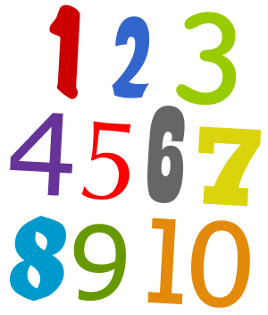  Making pairs  Combining 2 groups | Log on to  https://whiterosemaths.com /homelearning  Click on Early Years  Click on  Growing 6,7,8 Week 2  Matching 6,7 and 8  Click on Session 1 – watch the video and then complete the activity by clicking on  Get the Activity |  | Log on to  https://whiterosemaths.com /homelearning  Click on Early Years  Click on  Growing 6,7,8 Week 2  Making pairs  Click on Session 2 – watch the video and then complete the activity by clicking on  Get the Activity |  | Log on to  https://whiterosemaths.com /homelearning  Click on Early Years  Click on Growing 6,7,8 Week 2  Combining two groups  Click on Session 3 – watch the video and then complete the activity by clicking on  Get the Activity |  | Log on to  https://whiterosemaths.com /homelearning  Click on Early Years  Click on  Growing 6,7,8 Week 2  Combining two groups  Click on Session 4 – watch the video and then complete the activity by clicking on  Get the Activity |  | Log on to  https://whiterosemaths.com /homelearning  Click on Early Years  Click on  Growing 6,7,8 Week 2  Adding more  Click on Session 5 – watch the video and then complete the activity by clicking on  Get the Activity
Children’s Mental Health Week Book  Pass it On  Listen to it again on You Tube  https://www.youtube.com/watch?v=RBvy9nK2q3E |  |  |  |  |  |  |  | 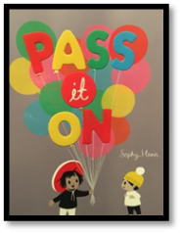
Writing  Attempts to write short sentences in meaningful contexts |  | Express Yourself Week  Exploring and Using Media and Materials  Manipulates materials to achieve a planned effect |  | Express Yourself Week  Exploring and Using Media and Materials  Manipulates materials to achieve a planned effect |  | Understanding the World  Technology  Completes a simple programme on a computer |  | Express Yourself Week  Dress to Express Day  School Talent Show
Think about the story  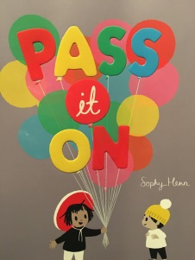  What things make you happy?  Draw a picture in your book of things / people that make you happy and write about why.  OR  Keep a Happiness Journal this week ( template on website )  Don’t forget to use your phonics knowledge, finger spaces and full stops.  Additional challenge  Use capital letters at the beginning of your sentence |  | School Art Project-Superhero  Express yourself as a superhero. Which one would you be?  Design a costume and make yourself some Superhero cuffs  https://laughingkidslearn.com/how-to-make-superhero-cuffs-using-toilet-roll-tubes/  Nature project  Make a bird feeder to help feed the birds during the cold weather  Watch - How to make three  recycled bird feeders with Maddie Moate on You Tube  or copy and paste the link below  www.youtube.com/watch?v=CW7UYp9kLi0 |  | School Art Project–Superhero  Design a costume for your Superhero sidekick/ friend. Make them a superhero mask.  Make your own worry toy  A worry toy is something that children can use to tell their worries to - the worry toy then take their worries away. This might be a way to encourage children to talk about how they’re feeling about things at the moment.  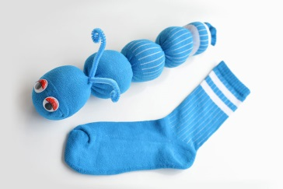  Watch the video on You Tube  https://www.youtube.com/watch?v=zFDf_GCOuOs |  | School Art Project–Superhero  Design your own Superhero  Log into Top Marks  www.topmarks.co.uk  Search  Heroes  Style a Hero  Create your own super hero. Choose what your hero looks like and wears.  2pm  Achievement Assembly |  | Fancy Dress Day  Dress to Express  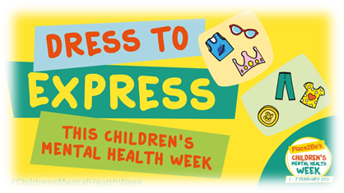  Encourage the children to express themselves through their clothes, hair etc. They could wear different colours, their favourite colour or choose a range of colours to express how they are feeling. It could be very personal and mean different things to different people. It could be fancy dress of their favourite character, superhero etc.  School Talent Show

