Homework – Friday 6th November 2020
These are the three sounds we have learnt this week in phonics ( together with the actions ). We have also covered ‘ck ’as in clock, sock, duck.
Please could you ask your child to repeat them to you at home and then look for things around the house and outside that begin with that sound / contain the sound. This will help reinforce the skill of hearing the sounds in a word. They should also practise writing the letters – please use the catchy phrases that we have provided to help them with letter formation.
By now some children may also be ready to write some simple words using the letters they have learnt over the last few weeks. If so please encourage them to ‘have a go’ at these at home.
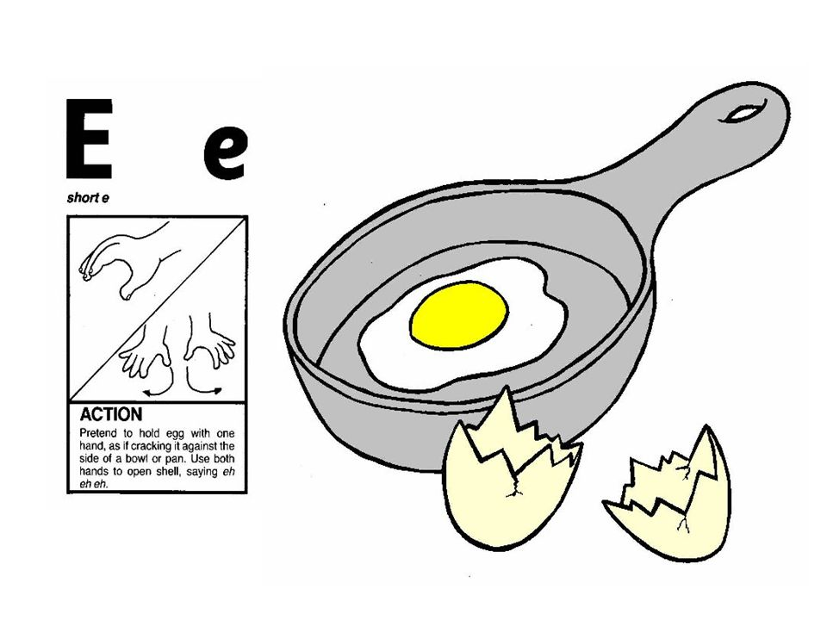 | 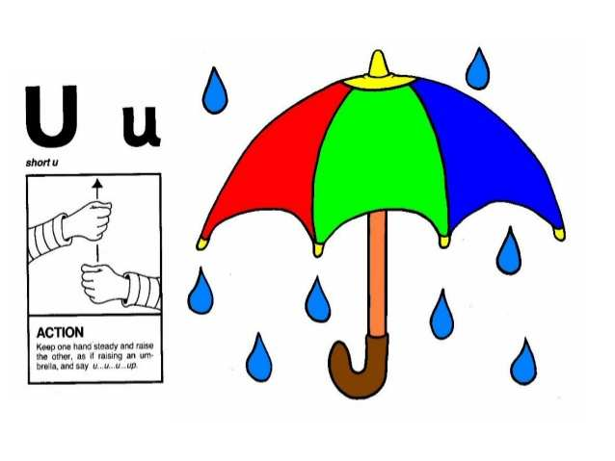
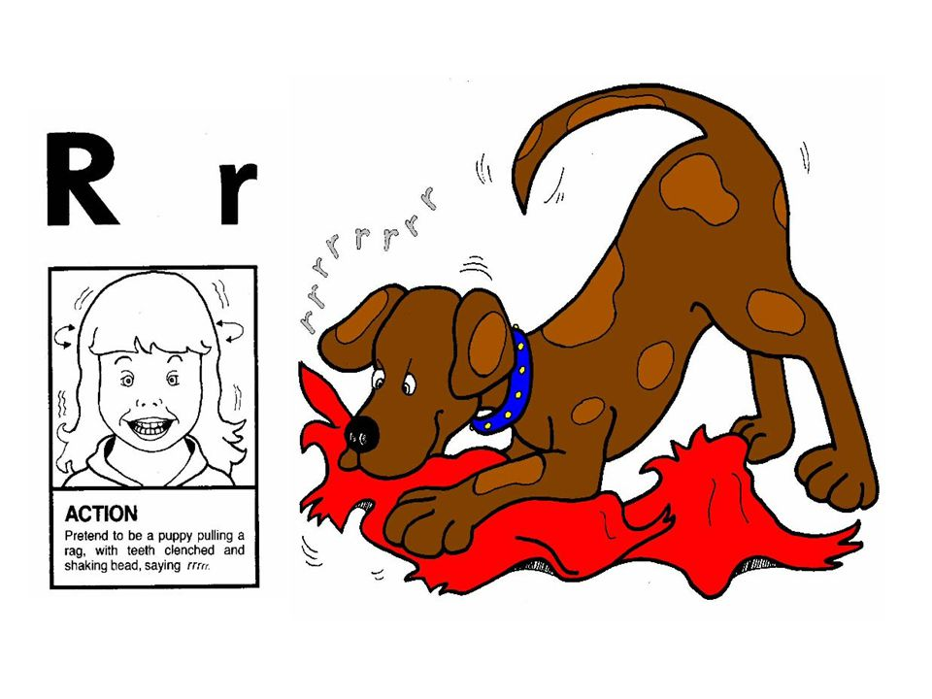 | 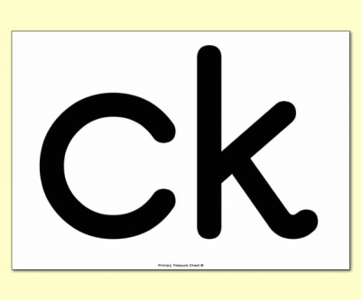

Please let us know how your child got on with this task by sending a brief comment, by Monday.
receptionlearning@farnborough.bromley.sch.uk
Many thanks,
Mrs Holmes

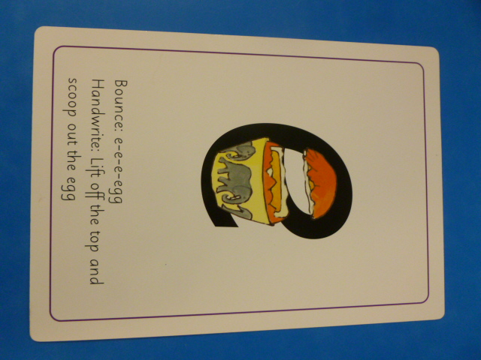 | 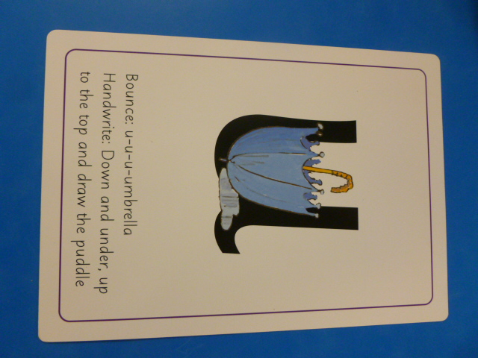
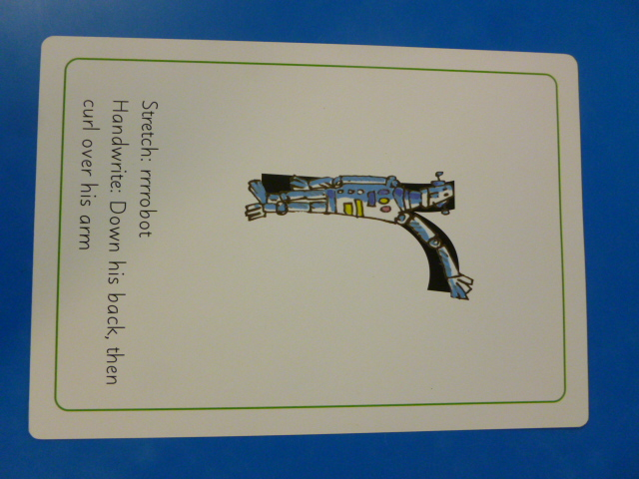 | 