Homework – Friday 23rd October 2020
These are the four sounds we have learnt this week in phonics ( together with the actions ). Please could you ask your child to repeat them to you at home and then look for things around the house and outside that begin with that sound. This will help reinforce the skill of hearing the initial sound in a word. They should also practise writing the letters – please use the catchy phrases that we have provided on the next page to help them with letter formation.
By now some children may also be ready to write some simple words using the letters they have learnt over the last few weeks. If so please encourage them to ‘have a go’. Words you could ask them to write could include any of the following – sit, tap, pan, tin, mat, dad, pig, dog, cat, kit
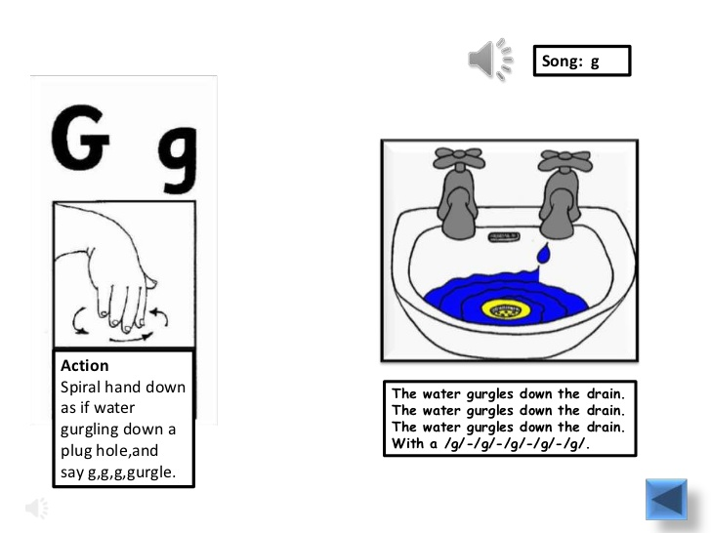 | 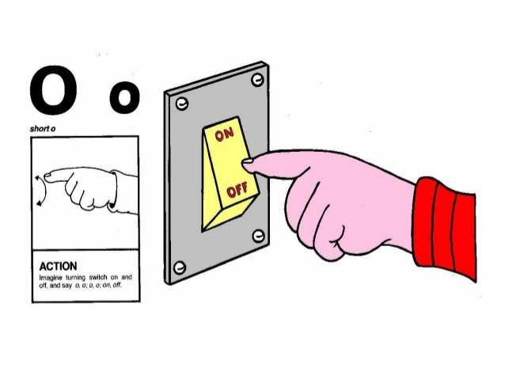
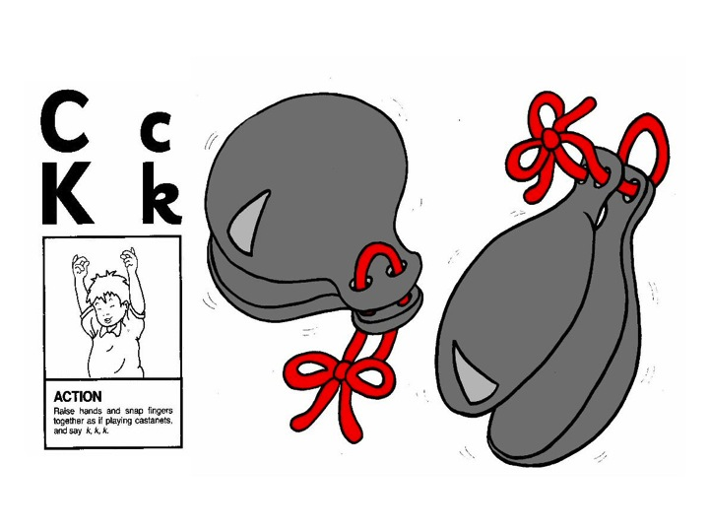

Please let us know how your child got on with this task by sending a brief comment, by Monday 2nd November, to
receptionlearning@farnborough.bromley.sch.uk
Many thanks,
Mrs Holmes
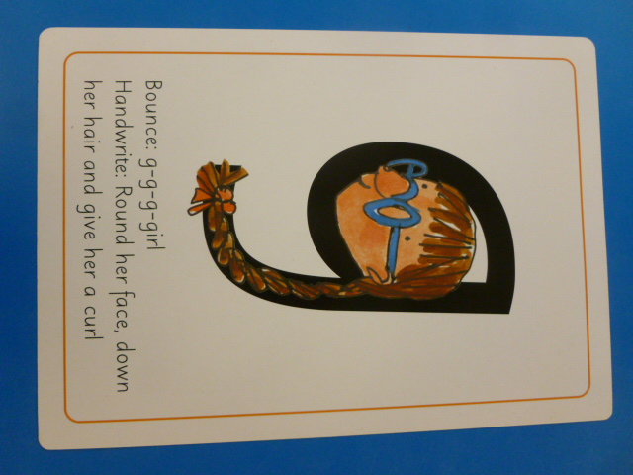 | 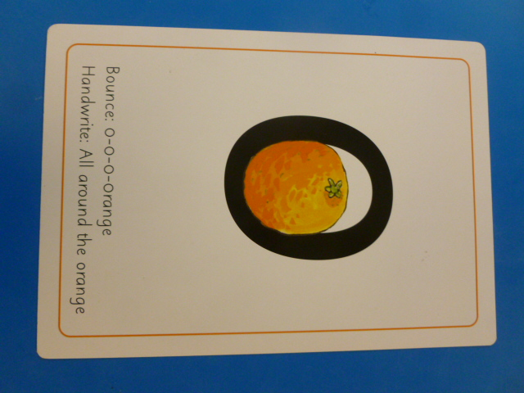
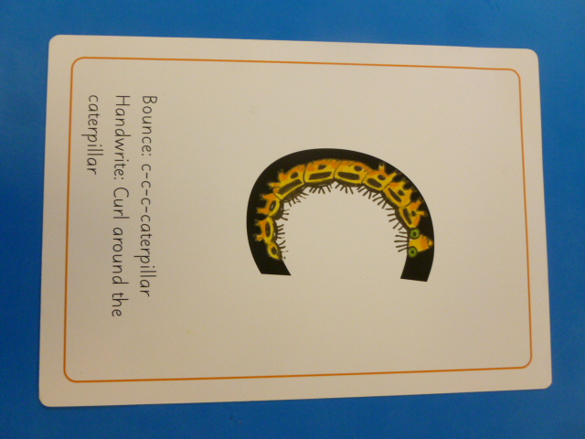 | 