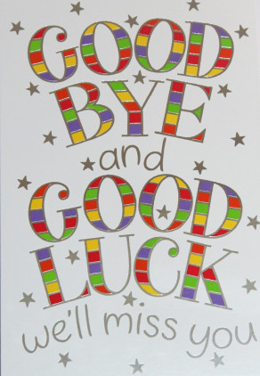
We hope that you all had a lovely weekend and are looking forward to the week ahead, your last week in Reception!
It’s been quite a year, we’re sure you’ll agree, and we are very sad that we didn’t get the opportunity to have the full year with your children or to share with them all the experiences that we had planned. They are a lovely class and we will really miss them but we know that they will have a wonderful time when they are all back together again with Mrs Murray in Year 1.
Thank you so much for all you have done with your children during Lockdown – you have been amazing!
The year group e-mail will remain open until the end of the week and so you will still be able to share any messages and receive responses. receptionlearning@farnborough.bromley.sch.uk
Our last Class Zoom will be on Wednesday at 11.30 – we hope to see you there.
In the meantime we wish you all a happy and safe summer. Mrs Holmes , Mrs Edwards and Mrs Fairley

