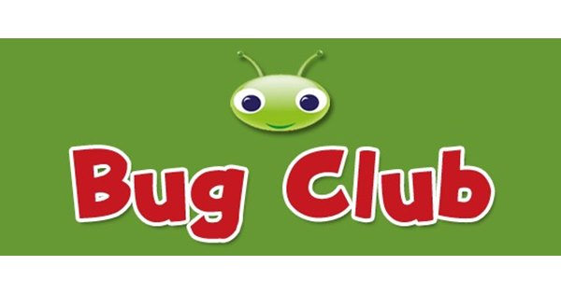
Summer Holidays
We are pleased to inform you that we have decided to keep the Bug Club website open for reading over the summer for those children in Reception and Key Stage 1 that want to continue to access it.
We will try to update it as often as we can but please be patient with us if this doesn’t happen as regularly as it has as we will officially be on holiday too and may also not have easy access to the internet over the whole of the break.

Kind Regards,
Mrs Holmes, Mrs Murray and Mrs Matthews

