Follow the instructions and rotate these arrows. Draw their final position.
Turn the arrow ¼ turn clockwise. | 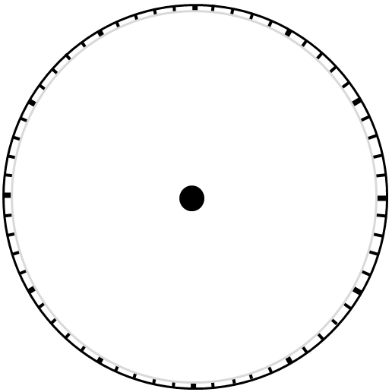
Turn the arrow ¼ turn anti-clockwise.

Turn the arrow ½ turn clockwise.

Turn the arrow a full turn anti-clockwise.

Turn the arrow ¾ turn clockwise.

Turn the arrow ¾ turn anti-clockwise.

Turn the arrow ¼ turn anti-clockwise.

Turn the arrow a ¼ clockwise.

Turn the arrow a ¾ anti-clockwise.

Turn the arrow a ½ clockwise.

This bug has rotated.
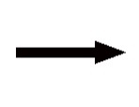
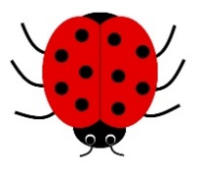
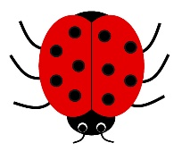

Anne says. ‘The bug has made ½ turn clockwise.’
Ben says, ‘The bug has made ½ turn anti-clockwise.’
Who is right? ________
Why?

