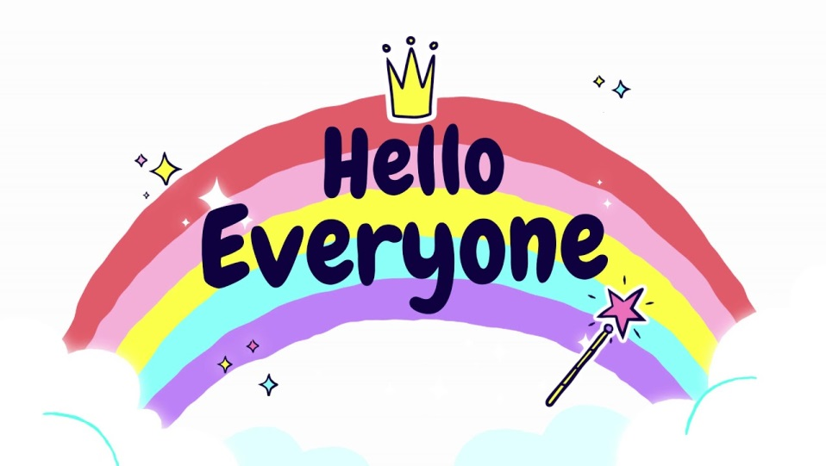
I think over the last two weeks I have managed to speak to nearly everyone on the phone – it has been great to talk to you all and to find out first-hand what everyone’s been up too. Don’t forget that we have now also set up an e-mail address just for Reception and this is checked and responded to daily. As per Miss James’ letters dated 24th and 28th April we are encouraging you to send photos of your children’s work to us on a daily basis so that your child can have some feedback from their teacher.
receptionlearning@farnborough.bromley.sch.uk
Thank you to everyone who has been exploring the new Phonics website ( details on how to join under Week 4 Home Learning ) – it seems that the children have really been enjoying it. Also don’t forget to sign up for Maths with Parents too if you haven’t done so already ( details under Week 3 Home Learning ).
There are some additional messages for the children on the next two pages from the rest of the Reception Team too this week. They are all missing you all too…..
With my best wishes to you all, have a good week , Mrs Holmes

From Mrs Edwards
Wow - it’s been so long since I’ve seen you all. I am missing you so very much and cannot wait to see you and your families again very soon. I hope you are all entertaining each other when you’re not busy with your home learning. Take good care of yourselves, look after each other and be kind. With love and very best wishes to you all.
From Mrs Fairley
Hello Pixies! I can’t tell you just how much I’ve missed seeing you all and hearing all your wonderful stories. I hope that you’ve been keeping yourselves busy working through your school activities and managing to enjoy some time off too. I thought that the milk bottle Elmer project was too exciting to miss - so I had a go at making one too. I’ve also planted some sunflower seeds which are just starting to spring up. I’ll keep you updated on their progress. Keep busy, keep smiling, but above all, keep safe. I’m sending my love to each of you and your families.
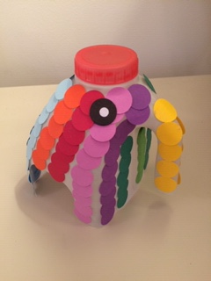 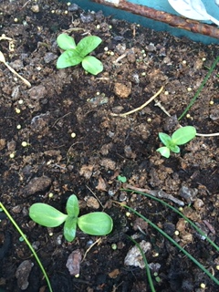

From Miss Stockwell
To the lovely Pixie Class
I just want to say a huge ‘ Hello’ to you all , I miss seeing all your happy faces every day at school, but I know you will all be working very hard and having lots of fun at home. I am really looking forward to hearing all about your time at home when we go back to school. But for now I am sending you my very best wishes and a great big smile.
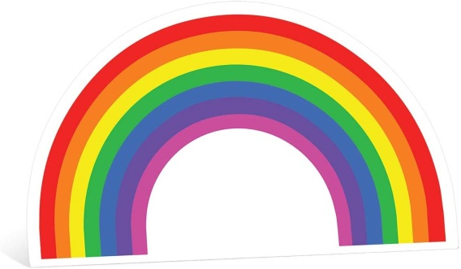

From Mrs Welensky
Dear Pixies
I hope you are all safe and well, and enjoying the beautiful sunshine. Having just moved house the Welensky home is full of cardboard boxes! They remind me of how creative and resourceful you all are. I can’t wait until we are all back at school and junk modelling together again. Every time I see a rainbow in a window I think of our beautiful, bright Reception class. Love to you all and I hope to see you soon.

