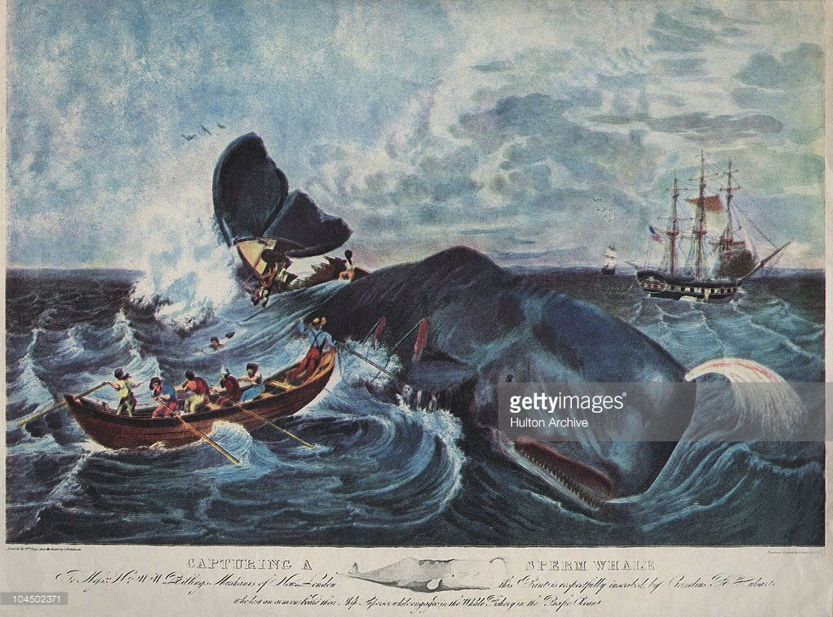
Skills shown: quick-thinking, bravery, resilience, endurance
Story:
- Able seaman on a whaling boat
- Captain sends out 2 boats to capture whale in rough seas
- My boat gets smashed by tail
- 4 crew in freezing water, manage to swim/drag other 3 to the other boat to be rescued.

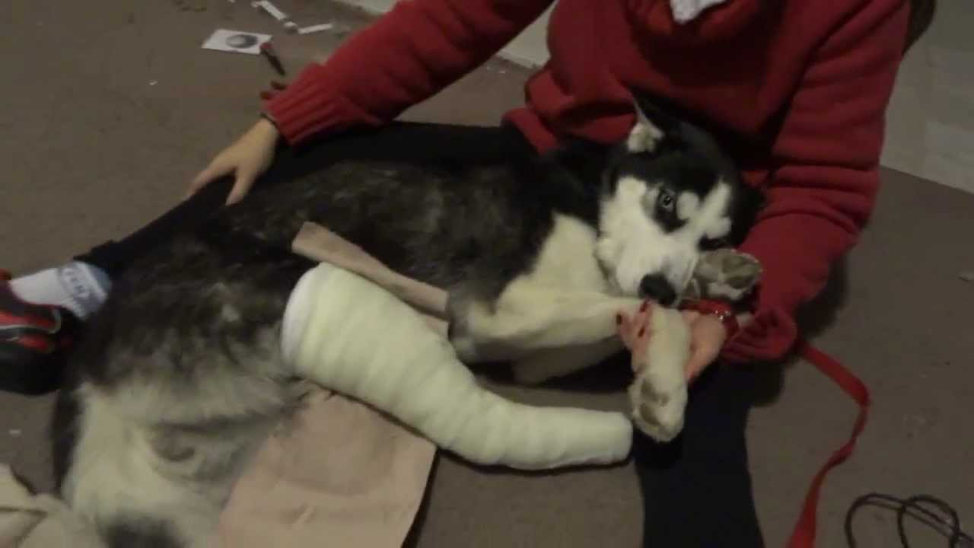
Skills shown: kindness, determination, patience, respect, facing difficult odds
Story:
- Father was a settler in Canada and kept huskies to pull a sledge so he could get around
- Terrible accident and the lead dog broke its leg
- Father said to kill it but as I had raised it from a puppy I wanted to look after it.
- Took it back home, added a splint to its leg and stayed up with it for 3 days to look after it while it suffered from a fever
- In 6 months, the dog had returned to sledge and was as fit as ever

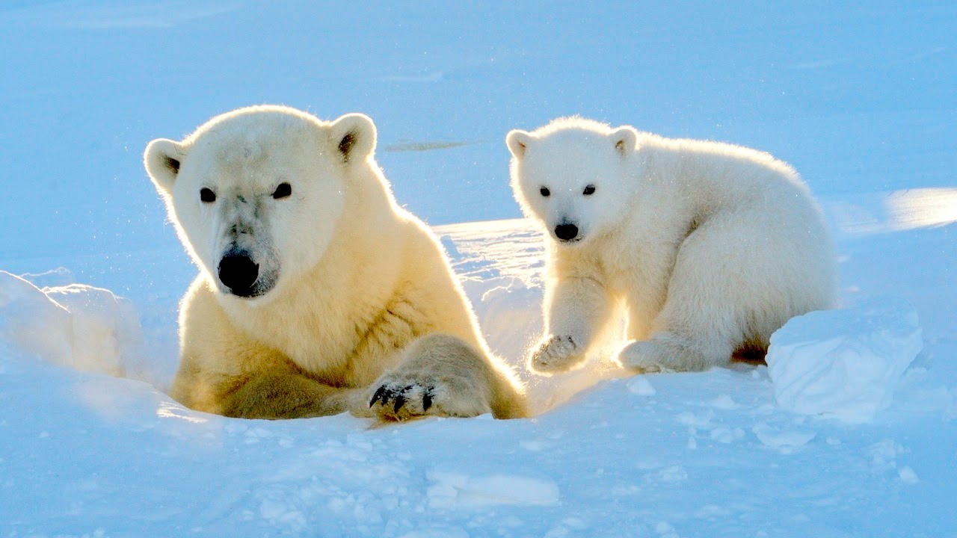
Skills shown: patience, commitment, confidence, achievement, surviving cold
Story
- Wildlife photographer
- Sent to Arctic to photograph polar bears
- No one had photographed a cub before in the wild, decide to travel further North than any camera man had before to search
- 3 months of tracking a pregnant polar bear and finally managed to find a hiding spot where the bear could not see or smell me
- Spent 3 days awake with my finger on the camera button ready to get the shot. Finally got the shot, the first one ever. I had been so determined my finger had frozen onto the camera button!

