Reading | Log on to Bug Club  Read for minimum 15 minutes  Answer ‘bug’ questions.
Handwriting | Complete the indicated page in your handwriting book.
Phonics | Read through the Phonics slides and complete the indicated pages in your phonics book.
English | Read through the English slides and complete the activity set.
Maths  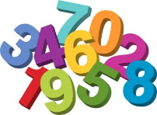 | Read through the Maths slides and complete the indicated pages in your maths book. Additionally, games on Busy Things will be given, activities on School Jam sent to parents’ phones and Times Tables Rock stars practise is available.
Active Learning | PE activities  DT – Cooking, making, junk modelling  Art – drawing, sketching  Science STEM activities
Dear Parents,
Below shows the daily work which is set for your child whilst he/she is at home during this period. Please click on work link to find the slides.

