Guided Reading | Read for minimum 10 minutes, either a book of your choice or your school reading book and record in your reading record.  Complete guided reading activity set on website. (20mins)
Handwriting | 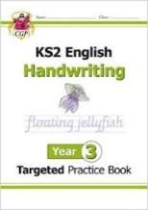  Complete the indicated page in your handwriting book (you will find this on the final slide of the guided reading activity). (15mins)
English  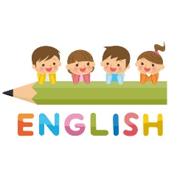 | Read through the English slides and complete the activity set. (45mins)
Maths  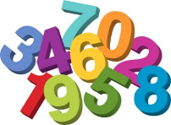 | Read through the maths slides and complete the activity set or a page from your maths workbook (if you have been given one).  Additionally, you could play games on TT Rock Stars and hit the button. (45mins)
Active Learning or Foundation subject. | PE activities  DT – Cooking, making, junk modelling  Art – drawing, sketching  Science  Topic  French  We will set one of the above each day on the website. (45mins)
Dear Parents,
Below shows the daily work which is set for your child whilst he/she is at home during this period. Please click on work link to find the slides.

