I would like you to write a postcard as Halfdene to his wife. Describe his thoughts and emotions at what he has found in Constantinople.

Below is what we wrote together on Wednesday:

Dear Hilde,

How are you? Constantinople is the most amazing place I have ever visited. I'm sure you would love it as well, the silks here are almost as beautiful as you!

The market is beyond belief. The things they sell are nothing like you would get at home. In one of the markets, they sell so many exotic spices. There are romantic and fragrant smells and the colours are so vivid it overpowers you.

Remember to also discuss:

* The number of people in the market
* How beautiful the Hagia Sophia is
* What the journey was like

Here is the clip to remind you:

<https://www.bbc.co.uk/education/clips/zy9d2hv>

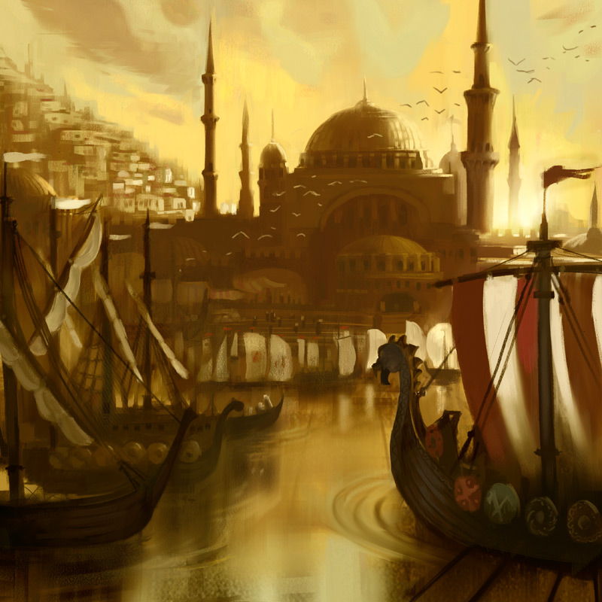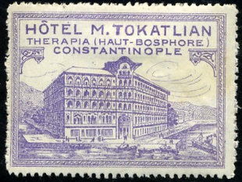

*Hilde Sigmundsen*

*Nordvegen*

*Norway*